**Scotland Deanery Newsletter**

Issue 49 | April 2025

**Content**

1. Foreword
2. Resident Doctor Webinar – ARCPs
3. GMC National Training Survey
4. NES Conference 2025
5. Two new CPD Connect eLearning Modules: Menstrual Health and Menopause
6. Scotland Deanery Website
7. Sexual Offenses: Working Together Best Practice Update for Scotland Conference
8. Educational Events on Topics Related to Bereavement
9. 2024/25 Scottish Medical Appraisers Conference
10. The Knowledge Network – exciting updates from your digital library!
11. Valuing Diversity and Promoting Inclusivity
12. Please Contact Us
13. NES Websites
14. **Foreword**

**Welcome to the April edition of the Deanery newsletter.**

Spring has now definitely sprung! It contrasts with the colder weather we have had recently and hopefully sets us up for a wonderful summer.

First of all, we have details of the first in a series of monthly resident doctor webinars hosted by the NES Medical Senior Team which took place in April. All resident doctors are invited. The weblink gives you access to the recording of the webinar and Q&As from the event. The next webinar will be in May and all resident doctors will receive an invite.

The NES Virtual Annual Conference 2025 includes many sessions directly relevant to medical education and training. Many of the sessions will be recorded and it is always worth looking back and watching if you were not able to participate on the day.

Next, we introduce two new NES CPD Connect eLearning modules on Menstrual Health and Menopause. We hope you find these new resources useful in your work.

The Scotland Deanery website is an essential resource for resident doctors. The item discusses what information you can find there and encourages you to pay a visit. Feedback on the website is always welcome and there. The feedback link is in item 11 in this newsletter.

NES Medical Directorate hosted an extremely successful conference on Sexual Offences recently. and the article discussed what was discussed. This was a national hybrid conference on 19th March 2025 in collaboration with Scottish Government.  The conference was attended by professionals working within forensic medical services across Scotland.

Our next item discusses a virtual learning event that aims to help us get bereavement right every time, be it a patient, patient’s family or colleague. This is aimed at all who experience this, including patient facing roles. Also included in the item are details of the 2025 Bereavement conference in November, what it involves and how to receive updates.

The NES Scottish Medical Appraisers conference took place in February and this item discusses the form and gives access to recordings from the event.

NES Knowledge Services is a fantastic resource. In this article the team behind the NES Knowledge Network are delighted to provide an update on the subscriptions available to health and social care staff in Scotland via the digital library.

I hope you enjoy this edition.

Best regards,

Professor Emma Watson

Executive Medical Director



If you have work you would like to highlight in this newsletter, contact [**Scotland Deanery**](https://www.scotlanddeanery.nhs.scot/contact/).



1. **Resident Doctor Webinar – ARCPs**

The first of a monthly series of Resident Doctor webinars, hosted by the NES Medicine senior team, was held on 3 April 2025.



The main topic was ARCPs.

Please see the recording and Q & As here: [Recap: Resident Doctor Webinar 03 April](https://eur01.safelinks.protection.outlook.com/?url=https%3A%2F%2Fteams.microsoft.com%2Fl%2Fmeetingrecap%3FdriveId%3Db%25217aTmQQ0xfEKYxPOwIAO0TzcNTAkc_UxGiiKEmgVFYw9RmWDaLUOrQrHWGeH6Cpc3%26driveItemId%3D01VTGZG3JYC2NQP6W3IRAZ2J3URKIOK3TV%26sitePath%3Dhttps%253A%252F%252Fscottish-my.sharepoint.com%252F%253Av%253A%252Fg%252Fpersonal%252Flisa_pearson_nes_scot_nhs_uk%252FETgWmwf620RBnSd0ipDlbnUBk5xnDxwtLMBQtsJRjCeHmA%26fileUrl%3Dhttps%253A%252F%252Fscottish-my.sharepoint.com%252Fpersonal%252Flisa_pearson_nes_scot_nhs_uk%252FDocuments%252FRecordings%252FResident%252520Doctor%252520Webinar-20250403_163241-Meeting%252520Recording.mp4%253Fweb%253D1%26iCalUid%3D040000008200E00074C5B7101A82E00800000000D063A9185181DB01000000000000000010000000DA7164378B780246B21E9B23A0DC17E3%26threadId%3D19%253Ameeting_YTMxMGNiZjctZmZjOC00M2NkLWI2NGItYjZkOTQ3MmVmMmEy%2540thread.v2%26organizerId%3Db9a18bb1-0ab3-40cd-863e-2dad7c134539%26tenantId%3D10efe0bd-a030-4bca-809c-b5e6745e499a%26callId%3De77d8a70-fbd1-4a40-a2de-c064070b3a7f%26threadType%3DMeeting%26meetingType%3DScheduled%26subType%3DRecapSharingLink_RecapCore&data=05%7C02%7CGemma.Cornall%40nhs.scot%7Caba378a7541942ae575208dd7761b51c%7C10efe0bda0304bca809cb5e6745e499a%7C0%7C0%7C638797983720718904%7CUnknown%7CTWFpbGZsb3d8eyJFbXB0eU1hcGkiOnRydWUsIlYiOiIwLjAuMDAwMCIsIlAiOiJXaW4zMiIsIkFOIjoiTWFpbCIsIldUIjoyfQ%3D%3D%7C0%7C%7C%7C&sdata=5WRPb2LVM3T%2B3LxyThA%2BMHYZtuhLFxczZW%2FUVoBE2PY%3D&reserved=0)

Please see the Q & As here: [Resident Doctor April Webinar Q & As](https://eur01.safelinks.protection.outlook.com/?url=https%3A%2F%2Fwww.scotlanddeanery.nhs.scot%2Fmedia%2F891882%2F2025-04-03-arcp-resident-doctor-webinar-3rd-april-2025-qa-and-useful-information.docx&data=05%7C02%7CGemma.Cornall%40nhs.scot%7Caba378a7541942ae575208dd7761b51c%7C10efe0bda0304bca809cb5e6745e499a%7C0%7C0%7C638797983720762954%7CUnknown%7CTWFpbGZsb3d8eyJFbXB0eU1hcGkiOnRydWUsIlYiOiIwLjAuMDAwMCIsIlAiOiJXaW4zMiIsIkFOIjoiTWFpbCIsIldUIjoyfQ%3D%3D%7C0%7C%7C%7C&sdata=xw%2FjUuF%2FM%2BsCc6rRP%2FQ10yMUCb8hzyPIWv%2B4XauLhB4%3D&reserved=0)

Resident doctors will receive an invite to all monthly webinars.

Future topics to include:

* Research opportunities in parallel to clinical duties
* Leadership opportunities for resident doctors

1. **GMC National Training Survey**



The GMC run the national training survey every year to gain a comprehensive picture of the experiences of doctors in training and trainers across the UK. The survey is a core part of our work to monitor and report on the quality of postgraduate medical education and training.

[**Complete the 2025 survey**](https://www.gmc-uk.org/online)

The survey is open now until Tuesday 29th April 2025. The survey is a core part of the NES Quality workstream’s work to improve the quality of postgraduate medical education and training across Scotland and your engagement with the survey is very much appreciated.

1. **NES Conference 2025**

## ****Learning for Change: Tackling Health Inequity through Education and Workplace Learning****

## **24 & 25 April 2025**



## ****NES Annual Conference 2025 - Learning for Change: Tackling Health Inequity through Education and Workplace Learning****

**Thursday 24 and Friday 25 April 2025**

Following on the growing success of the 2024 conference, NES is delighted to confirm that it will once again be hosting the conference online over two days in April 2025.

This conference is for colleagues from all professional disciplines across health and social care with an interest in education and training, workforce development and digital solutions.

There will be a number of plenary and parallel sessions run by all professional groups and an opportunity for joint sessions highlighting interprofessional learning. NHS Education for Scotland sponsor the conference, and there will be no charge for participation.

Further details on the programme and how to register are available here: [**NES Annual Conference 2025**](https://www.nes.scot.nhs.uk/events/nes-annual-conference-2025-learning-for-change-tackling-health-inequity-through-education-and-workplace-learning/)

1. **Two new CPD Connect eLearning Modules: Menstrual Health and Menopause**

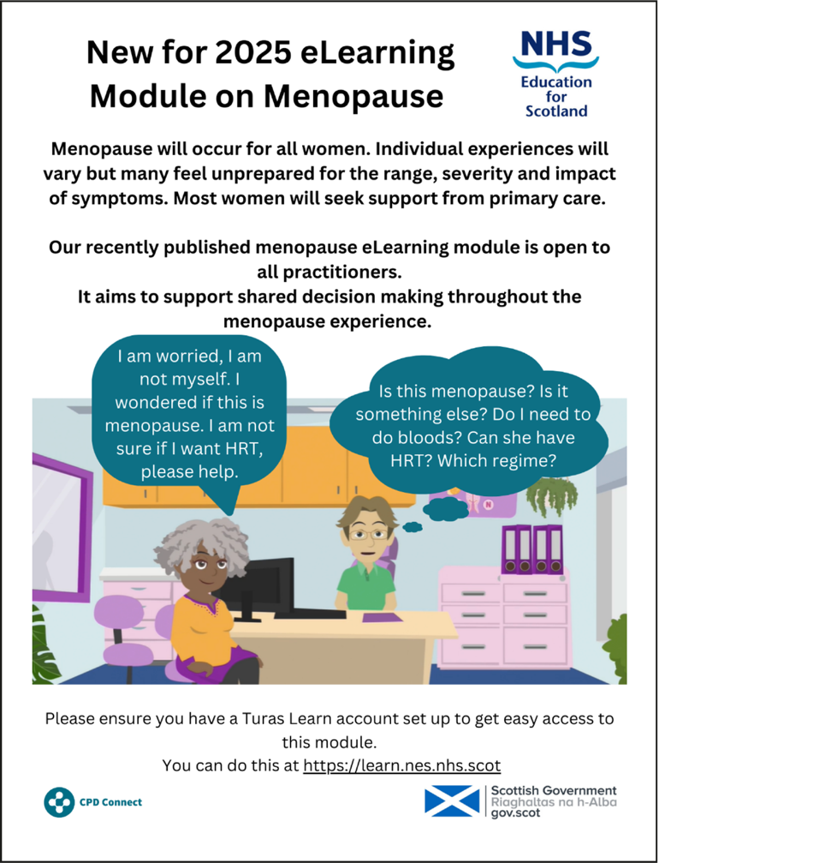

These modules are now available on Turas Learn:

[**Menstrual Health Module**](https://eur01.safelinks.protection.outlook.com/?url=https%3A%2F%2Flearn.nes.nhs.scot%2F76736&data=05%7C02%7CNiall.MacIntosh%40nhs.scot%7Ce9ada6326ae0416cbf8508dd71e2d194%7C10efe0bda0304bca809cb5e6745e499a%7C0%7C0%7C638791941180917486%7CUnknown%7CTWFpbGZsb3d8eyJFbXB0eU1hcGkiOnRydWUsIlYiOiIwLjAuMDAwMCIsIlAiOiJXaW4zMiIsIkFOIjoiTWFpbCIsIldUIjoyfQ%3D%3D%7C0%7C%7C%7C&sdata=QI04m64rrrzCH6rmEgP1PwJ60cvTjCfbU1%2F4B14mS7k%3D&reserved=0)

[**Menopause Module**](https://eur01.safelinks.protection.outlook.com/?url=https%3A%2F%2Flearn.nes.nhs.scot%2F76738&data=05%7C02%7CNiall.MacIntosh%40nhs.scot%7Ce9ada6326ae0416cbf8508dd71e2d194%7C10efe0bda0304bca809cb5e6745e499a%7C0%7C0%7C638791941180938568%7CUnknown%7CTWFpbGZsb3d8eyJFbXB0eU1hcGkiOnRydWUsIlYiOiIwLjAuMDAwMCIsIlAiOiJXaW4zMiIsIkFOIjoiTWFpbCIsIldUIjoyfQ%3D%3D%7C0%7C%7C%7C&sdata=%2B9DIl6AwcC0NSTQslPgoJSj97fcBNZUlB5MGJ1wOKz0%3D&reserved=0)

These are free to access and open to all practitioners in Scotland.  These are designed as complementary modules; therefore, you may wish to access Menstrual Health first.

All you need is a Turas Learn account which can be set up [**here**](https://eur01.safelinks.protection.outlook.com/?url=https%3A%2F%2Fnhsefs.b2clogin.com%2Fnhsefs.onmicrosoft.com%2Fb2c_1a_turas_signup_prd%2Foauth2%2Fv2.0%2Fauthorize%3Fclient_id%3Dc012c0a5-88e3-4681-a9d9-617ba36d2011%26redirect_uri%3Dhttps%253A%252F%252Fturasdashboard.nes.nhs.scot%252F%26response_type%3Did_token%26scope%3Dopenid%26state%3DOpenIdConnect.AuthenticationProperties%253DFonxqJ2R6JCZGwkY6eMprK-kLVNz_OeuOyMz5nW4KhDIiSGMGG8Vyp01QRwTzOqMC2qTNuAvhpuNa0qb_IeurH3VnSCAeRT5yQzJ8A5eKB5SsbLadX6jvuiRgVhR5yCFWsm2Dol6VmScPf_11AEWDeeya5MNjDyamE-L-2OBfodgLs2gIpwuGxhngJf6Inni%26response_mode%3Dform_post%26nonce%3D638646692979910146.YTdmYTM5ZTAtZDk4Yy00OWY0LWFlNDUtM2Y1MjdhNTZkOWFjNWNjYzMwZmEtNzc2OC00YjU4LTg1ZjMtOGY5YzdkZmYzMmNh%26OpenIdApplicationId%3Dc012c0a5-88e3-4681-a9d9-617ba36d2011%26x-client-SKU%3DID_NET461%26x-client-ver%3D5.3.0.0&data=05%7C02%7CNiall.MacIntosh%40nhs.scot%7Ce9ada6326ae0416cbf8508dd71e2d194%7C10efe0bda0304bca809cb5e6745e499a%7C0%7C0%7C638791941180951339%7CUnknown%7CTWFpbGZsb3d8eyJFbXB0eU1hcGkiOnRydWUsIlYiOiIwLjAuMDAwMCIsIlAiOiJXaW4zMiIsIkFOIjoiTWFpbCIsIldUIjoyfQ%3D%3D%7C0%7C%7C%7C&sdata=Ajc7%2BdevYeyOFpYTQrGLvdm5K0Se2EJVK4%2BMLr1pgrk%3D&reserved=0) if you don’t already have one. Should you experience any issues when registering, please access the Helpdesk located on the right-hand side of the webpage.

If you complete the module, we would be most grateful if you could complete the evaluation as we are keen to hear your thoughts.



If you have any queries, you can contact the CPD Connect team at: [**cpdconnect@nes.scot.nhs.uk**](mailto:cpdconnect@nes.scot.nhs.uk)



1. **Scotland Deanery Website**

Are you looking for information about your ARCP? Applying for less than full time training? Out of programme? Period of grace? – The Scotland Deanery website contains lots of useful information to help and support and resident doctors.

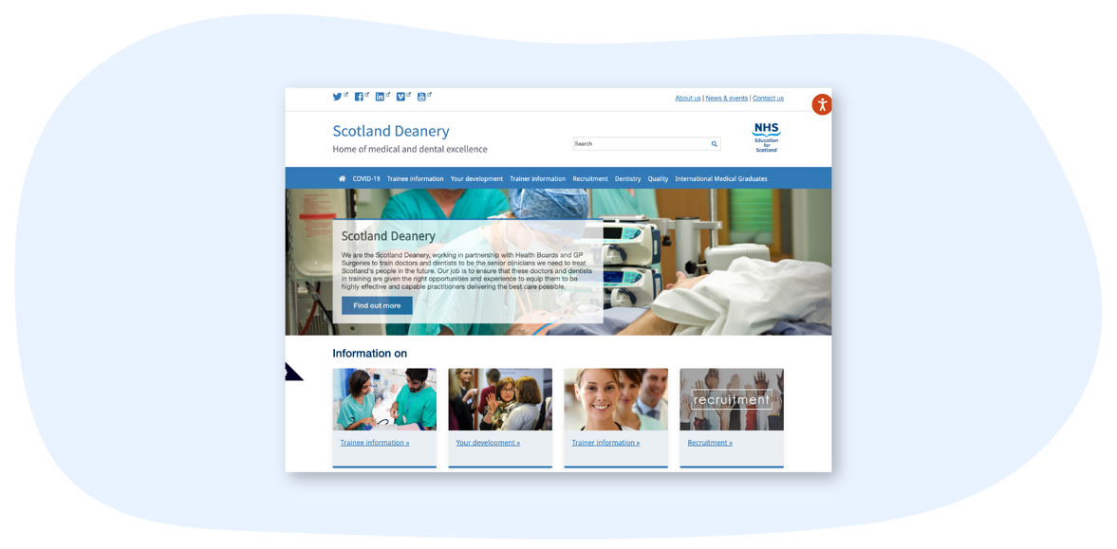

**Are you are considering applying for less than full time training, out of programme or wish to use a grace period?**

Please ensure you provide plenty of notice (see website for recommended timescales) to ensure all relevant approvals are in place. Also please reach out to your programme director or programme administrator if you have any questions. The website also has lots of information for our educators and we encourage you to visit the pages to support our trainers.



**Useful links**

The Scotland Deanery homepage - [**https://www.scotlanddeanery.nhs.scot/**](https://www.scotlanddeanery.nhs.scot/)

Resident doctor page - [**https://www.scotlanddeanery.nhs.scot/trainee-information/**](https://www.scotlanddeanery.nhs.scot/trainee-information/)

Educator Page - [**https://www.scotlanddeanery.nhs.scot/trainer-information/**](https://www.scotlanddeanery.nhs.scot/trainer-information/)

Programme Director Info - [**https://www.scotlanddeanery.nhs.scot/about-us/our-people/training-programme-directors/**](https://www.scotlanddeanery.nhs.scot/about-us/our-people/training-programme-directors/)

Programme Administrator info - [**https://www.scotlanddeanery.nhs.scot/about-us/our-people/training-management-team/**](https://www.scotlanddeanery.nhs.scot/about-us/our-people/training-management-team/)



1. **Sexual Offenses: Working Together Best Practice Update for Scotland Conference**



The Professional Development workstream within the NES Medical Directorate delivered a national hybrid conference on 19th March 2025 in collaboration with Scottish Government. The conference was attended by professionals working within forensic medical services across Scotland, including Sexual Offences Examiners, Forensically Trained Nurses, Police Scotland, Crown Office and Procurator Fiscal Service (COPFS) and other agencies working with people who have experienced rape or sexual assault. The conference was attended by 64 delegates in person and 80 online.

The programme included:

* Updates from the Sexual Assault and Referral Centres service (SARCS) Policy Unit and Network.
* Scot’s Law and Sexual Offences update from COPFS.
* Police Scotland presentation on Investigating ‘Stealthing’
* Viewing for in person delegates of the National Theatre Live one woman play ‘Prima Facie’, which explores themes related to the work of those attending the conference. The experience of the character in the play was then explored by both online and in person delegates through various breakout sessions.
* Challenges to Disclosure presentation by a Speciality Doctor/Sexual Offences Examiner from Archway Glasgow*) (delivered to online delegates on the day but recording shared with all registered post-conference*
* Forensic Sampling presentation by the National Lead Forensic Scientist for Sexual Offences from the Scottish Police Authority *(delivered to online delegates on the day but recording shared with all registered post-conference*
* Expert panel discussion about the challenges of disclosure and whether it is truly possible to minimise trauma in the process, as a reflection on the learning from the day.

Early feedback has been incredibly positive, and delegates valued the hybrid options for attendance and reported that they will be able to apply their learning to positively change their practice, particularly around observing and documenting distress, being aware of ‘stealthing’ and the legalities and ensuring trauma informed and person-centred care throughout.  The viewing of the Prima Facie play by the in person delegates was the subsequent workshops for all delegates have reportedly been very impactful.

Delegates reported the following about what they learned and the highlights of the day:

“Legalities and reporting re stealthing and importance of appropriately articulating 'distress'”

“I found the stealthing interesting, especially as it helps us see how what we do with a complainant translates into the court/a conviction.”

“Documenting and thinking about all the aspects of providing trauma informed patient centred card and for the future investigation and evidence giving.”

“The distress presentation to online participants was the most use as it will result in a major change of practice ... both in documentation ... but also in awareness”

“Reminded me why we do what we do.  I will take my learning to my colleagues”

“…..the conference made me feel more a part of the whole process and feel like we are a team working together.”

“Prima Facie - eye opening experience. Very powerful tool.”

This event was led by the Associate Postgraduate Deans for Forensics, Dr Deborah Wardle and Dr Nisha Krishnan, supported by the forensic administrative team and the NES Conference Team.



If anyone is interested in learning more about the work we do to support education for Forensic Medical Services, you can get in touch with the team at [**forensics@nes.scot.nhs.uk**](mailto:forensics@nes.scot.nhs.uk)



1. **Educational Events on Topics Related to Bereavement**

**Virtual learning session**

**Getting Bereavement Right Every Time**

* Wednesday 11th June 2025, 13:00-15:00

At work, we’re all likely to encounter someone who is bereaved, or a situation around the time of a person’s death at some point. This can include those working in non-clinical, administrative and other support roles, as well as staff in teams which are directly patient-facing.  
  
Knowing how to manage these situations is important – so we can support and help other people, whilst also looking after our own wellbeing. But thinking of what to say to someone who is bereaved may feel daunting.  
  
This session will provide an introduction to grief and bereavement. It may help those attending feel more confident in answering questions about bereavement such as:

* What should I say to someone who tells me they have recently been bereaved?
* Are there particular words I should or shouldn’t use?
* What if I say the ‘wrong’ thing?
* Is it normal to be upset if someone we know from work dies?

For more information and / or to register please visit: [**https://www.nes.scot.nhs.uk/events/getting-bereavement-right-every-time-webinar/**](https://www.nes.scot.nhs.uk/events/getting-bereavement-right-every-time-webinar/)

**Annual Conference**

**Bereavement as a Kaleidoscope – An Inclusive Approach for All**

* Tuesday 11th November 2025

Details are now available regarding this year’s Bereavement Education Conference, which will be the sixth that NES has hosted. Last year’s event saw over 1300 delegates register from across the world.

This year we will again be running a free, one-day virtual event.

**Submit an abstract!**

The abstract submission windows are now open for parallel sessions and for an e-poster exhibition. Don’t miss out on the opportunity to showcase your work.

For all information please visit: [**https://www.nes.scot.nhs.uk/events/bereavement-education-conference-2025-bereavement-as-a-kaleidoscope-an-inclusive-approach-for-all/**](https://www.nes.scot.nhs.uk/events/bereavement-education-conference-2025-bereavement-as-a-kaleidoscope-an-inclusive-approach-for-all/)

If you’d like to be added to a mailing list so you receive notifications e.g. when registration opens, please email [**events@nes.scot.nhs.uk**](mailto:events@nes.scot.nhs.uk)

1. **2024/25 Scottish Medical Appraisers Conference**



## The Scottish Medical Appraisers Conference was held this year on 3rd February 2025, hosted via MS Teams Webinar.  The event was attended by over 200 appraisers designed to aid their continuing professional development as medical appraisers.  After reviewing feedback collated across various sources, two workshops were delivered in partnership with Appraisal Leads and our course Tutors focusing on “Challenging Appraisal Situations” and “Exploring Form 4” in the new GMC Good Medical Practice domains.

## 

## Video recordings are published on the appraisal web pages <https://www.appraisal.nes.scot.nhs.uk/our-work/appraiser-conferences/>



**10. The Knowledge Network – exciting updates from your digital library!**

The team behind The Knowledge Network are delighted to provide an update on the subscriptions available to health and social care staff in Scotland via the digital library. During the last year, the team has been working hard to negotiate with suppliers and liaise with colleagues across NHS Scotland library services and NHS Education for Scotland - thank you to everyone who worked with us! As a result, we have successfully secured access for the next three years to the broad range of evidence, databases, journals and books that you need to provide quality care and develop professionally. We are also excited to share information about new resources which will now be included in our subscriptions.

**Evidence summaries**

In the last 12 months our users conducted roughly 570 searches and 1,568 page views per day on evidence summary resources, including BMJ Best Practice, DynaMed and ClinicalKey.

These services offer up to date, trustworthy evidence for use at the point of care. They also offer additional resources and services such as patient information, images and videos, and CPD tracking.

From April 2025 our users will also have access to the BMJ Best Practice Comorbidities Manager. This exciting new feature provides guidance on the treatment of acute conditions alongside a patient's pre-existing comorbidities. More guidance will soon be available on [**The Knowledge Network Evidence Summaries page**](https://www.knowledge.scot.nhs.uk/library-resources/evidence-summaries/).



**Journals**

In the last 12 months NHS Scotland OpenAthens account holders conducted 1,333,559 journal article downloads (that's 3,653 articles every day!).

We continue to provide access to over 4,000 journals, including key publications such as the BMJ collections, The Lancet, JAMA, Harvard Business Review, British Journal of Social Work and many more.

From April 2025 we will also be providing access to NEJM Evidence, a digital journal for innovative original research and fresh, bold ideas in clinical trial design and clinical decision-making.

To browse or search for titles of interest to you, use the [**Journal Search on The Knowledge Network Library Search**](https://browzine.com/libraries/3071/subjects?sort=rank).



**eBooks**

Users will continue to have access to ProQuest eBook Central Health and Medicine collection including around 20,000 curated titles, as well as new editions coming soon! Including the brand-new 15th edition of *The Maudsley prescribing guidelines in psychiatry*due to be published in April 2025*.*

We have also concluded the annual Joint National eBook purchasing project, in collaboration with NHS Scotland territorial and special boards. This year we have 149 additional titles, requested by our users and selected in consultation with NHSS knowledge managers.

Browse all recent editions with our [**2025 Books tag**](https://nhs.primo.exlibrisgroup.com/discovery/search?query=user_tags,exact,new%20ebooks%202025,AND&vid=44NHSS_INST:44NHSS_VU1&mode=advanced).



**Databases and collections**

Our users conducted nearly 700,000 Database searches last year across the range of popular databases we continue to have access to such as Medline, Embase, CINAHL, PsycInfo, ASSIA and Public health database.

We will continue to provide access to the Allied and Complementary Medicine Database (AMED) on a new platform.

As well as special collections such as Barbour for British and international standards and legislation and MindTools for leadership and management learning and development.

Browse all our collections via [**The Knowledge Network Library Search**](https://nhs.primo.exlibrisgroup.com/discovery/dbsearch?vid=44NHSS_INST%3A44NHSS_VU1&lang=en).



**Medicines information resources**

A wide range of essential medicines info resources continue to be provided, including BNF, Martindale, Palliative Care Formulary and many more.

In the last 12 months users downloaded an incredible 1,128,465 sections - that's over 3,000 downloads a day!

Access the full range of curated resources via [**The Knowledge Network Medicines Information page**](https://www.knowledge.scot.nhs.uk/library-resources/medicines-information/).



**Infographic**

We have created a handy infographic to showcase the resources available via The Knowledge Network and how NHS Scotland OpenAthens users have used them in the last 12 months

* [**The Knowledge Network digital library resources 2024-25**](https://www.knowledge.scot.nhs.uk/media/uchhbs4z/the-knowledge-network-digital-library-2024-25_infographic.png)
* [**Transcript - The Knowledge Network Digital Library Resources 2024-25 Infographic**](https://www.knowledge.scot.nhs.uk/media/ixfaq5ql/transcript-the-knowledge-network-digital-library-resources-2024-25_infographic.docx)



**Easy access**

The key to all of this is your NHS Scotland OpenAthens username, which is linked to all NHS Scotland staff email addresses and free to self-register for social care, local authority, health and social care students and partners in Scotland.

We also provide easy access to journal articles via LibKey - a special browser extension that links you to subscriptions from Google, Wikipedia and all over the web, so you can spend less time searching for the research you need.

NHS Scotland staff can request materials not in the Knowledge Network collection - details on how to do that can be found at: [**Finding and ordering external materials**](https://www.knowledge.scot.nhs.uk/help-and-training/information-skills/using-my-account/finding-and-ordering-external-materials/)

We now have an amazing 37,186 OpenAthens users - but we need more! Share this news with your colleagues so they can discover the huge range of resources made available to them via The Knowledge Network.

We'll be sharing more information and training opportunities for these resources in the coming months.

* For news and updates [**subscribe to our monthly Knowledge Nuggets newsletter**](https://mailchi.mp/nes/nuggets)
* Help to use the Library Search via [**Information skills**](https://www.knowledge.scot.nhs.uk/help-and-training/information-skills/)
* Register for our popular Finding information lunch and learn series via [**Training opportunities**](https://www.knowledge.scot.nhs.uk/help-and-training/training-opportunities/)
* For resources to promote The Knowledge Network see our [**About pages**](https://www.knowledge.scot.nhs.uk/about/promote-our-services/)
* If you have any questions, please contact the [**Knowledge Services Help Desk**](https://www.knowledge.scot.nhs.uk/about/contact-us/)
* NES Facebook - You can follow NES on Facebook here: [**NHS Education for Scotland (NES) | Edinburgh | Facebook**](https://www.facebook.com/NHSEducationforScotland/)

**11. Valuing Diversity and Promoting Inclusivity**

[**Inclusivity Poster**](https://scottish.sharepoint.com/sites/4nes/SPDS/Communications/Forms/AllItems.aspx?id=%2Fsites%2F4nes%2FSPDS%2FCommunications%2FDeanery%20Newsletter%2F2023%2FJune%202023%2F814870%5FSCT0922830498%2D001%5FInclusivity%5FPoster%5FP2%20%2D%20PRINTED%20VERSION%20%28002%29%2Epdf&parent=%2Fsites%2F4nes%2FSPDS%2FCommunications%2FDeanery%20Newsletter%2F2023%2FJune%202023&p=true&ga=1)

**12. Please Contact Us**

**FAO all trainees**

Please [**contact us**](https://www.scotlanddeanery.nhs.scot/contact/) with information on any initiatives and projects you are involved in that you would like to share with your colleagues across Scotland, or if you have feedback on the Deanery Newsletter or Deanery Websites.

**13. NES Websites**

**The Scotland Deanery Website**

On the [**Scotland Deanery website**](https://www.scotlanddeanery.nhs.scot/) for Scottish medical training there are sections with lots of relevant information for Trainees, Trainers, IMGs, Medical ACT, Quality and the Trainee Development and Wellbeing Service.

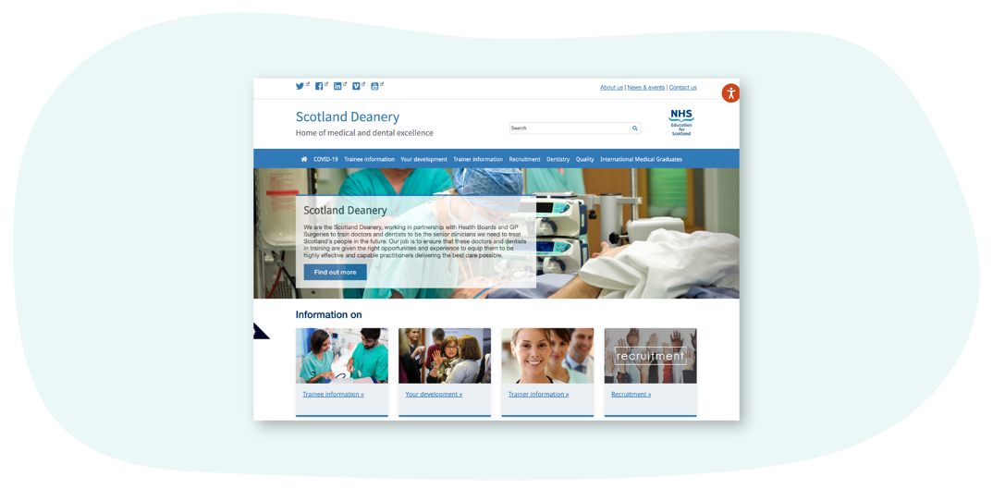



**Scottish Medical Training**

[**This site**](https://www.scotmt.scot.nhs.uk/) is our recruitment site and  is the principal resource to learn more about how to apply for Foundation, Core and Specialty Medical Training in Scotland. Here you’ll find regularly updated information about application windows (how and when to apply), a directory of 50+ GMC-approved medical specialty programmes and first-hand accounts about training from trainees and trainers. There are also useful insights on career direction and what it’s like training and working in Scotland.

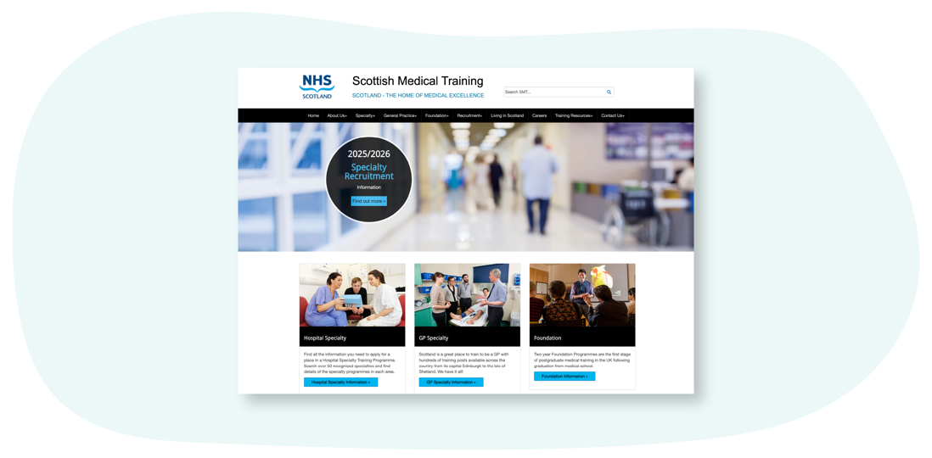

**Scottish Online Appraisal Resource (SOAR)**

Designed for doctors (in both Primary and Secondary Care) working and training in Scotland, for their Appraisal and Revalidation needs. The Scottish Online Appraisal Resource ([**SOAR**](https://www.appraisal.nes.scot.nhs.uk/)) is used by Appraisers and Appraisees to aid the appraisal process, and for Trainees to complete their self-declarations. Here you’ll also find a SOAR user guide, handy FAQ’s and examples of Quality Improvement Activities.

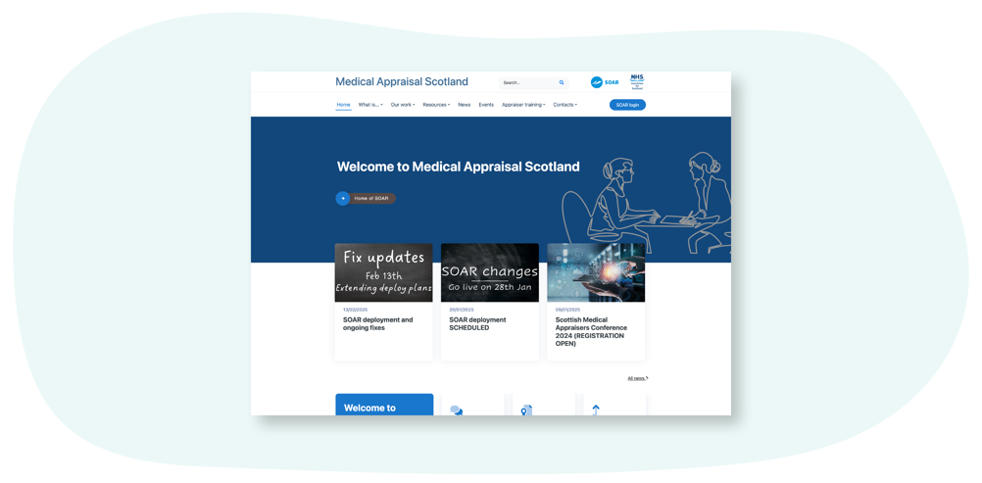



**Clinical Skills Managed Educational Network (CSMEN)**

[**This website**](https://www.csmen.scot.nhs.uk/) provides information and resources relating to the Clinical Skills Managed Educational Network (CSMEN) which was established in 2007 to support excellence in clinical skills education. The focus has been on improving patient safety and clinical outcomes by supporting access to high quality, multi-professional skills training and clinical simulation across all geographical areas of Scotland. CSMEN develops online educational resources**,**manages and deploys a Mobile Skills Unit (MSU) which provides state of the art simulation facilities for remote and rural healthcare practitioners and has built a national network of healthcare educators and practitioners. We connect people and organisations involved in health and social care to enable collaboration for a "Once for Scotland" approach to skills and simulation-based learning.

