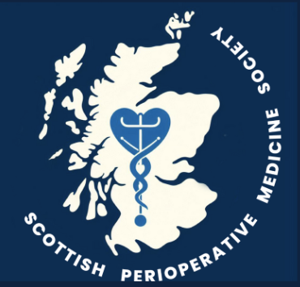 | Scottish Perioperative Medicine Society  Inaugural Annual Meeting June 2025  Abstract Submission Form
Abstract Title
Enter title here
Corresponding Author
Name |  | Enter your name here
Designation |  | Enter your designation here
Institution |  | Enter your institution here
Address |  | Enter your institution address here
Email |  | Enter your email address here
Submission to be considered for
Oral presentation |  |  | ☐ | You may select both forms of presentation if you wish, but if your abstract is accepted, it will only be in one category
Poster presentation |  |  | ☐
Completed forms should be emailed to: scotpoms@gmail.com
Closing date is Friday April 11th @ 5pm
Please send any queries to scotpoms@gmail.com
Please remember to register for the meeting if you have not already done so! Thank you

Abstract text (maximum 300 words)
Enter your abstract text here. You can copy and paste from another document if necessary

