Scottish Graduate Entry Medicine (ScotGEM)
ScotGEM Bursary Scheme - Information for Applicants

Content

- Who is eligible?
- Background
- Contract with NHS Scotland
- How do I apply?
- Contact us
- Frequently asked questions and answers

Who is eligible?

Any student who has been offered, formally accepted and has been registered for a place on the Scottish Graduate Entry Medicine (ScotGEM) programme.

Background

The ScotGEM programme, which has been accepting students since 2018, was Scotland’s first graduate entry, medical programme. ScotGEM offers a four-year Primary Medical Qualification (PMQ) programme which focuses on rural medicine and healthcare improvement and is designed to develop interest in a generalist career as a doctor working within NHS Scotland.

The Scottish Government introduced the ScotGEM Bursary to try and help address the shortage of NHS doctors in Scotland, with a focus on primary care and remote & rural medicine.

The ScotGEM Bursary Scheme is open to any student who is enrolled on the ScotGEM programme and who commits to the required return of service period within NHS Scotland. The scheme is administered by NHS Education for Scotland (NES) on behalf of the Scottish Government.

Contract with NHS Scotland

If you are awarded a ScotGEM Bursary, then you are entering into an obligation to apply to undertake Foundation and/ or Specialty training or other work as a doctor in the NHS, anywhere in Scotland.

The return of service period will vary depending on the number of years an individual claims the ScotGEM Bursary, as shown in the table below.
Number of years ScotGEM Bursary claimed | Amount of ScotGEM Bursary claimed | Length of return of service period*
4 | £16,000 | 4 years
3 | £12,000 | 3 years
2 | £8,000 | 2 years
1 | £4,000 | 1 year

*Based on working full time; graduates who work part time for any or all of their training will have these periods extended.

Repayment of the ScotGEM Bursary

If you are awarded a ScotGEM Bursary and fulfil the return of service period indicated, you will not need to repay the ScotGEM Bursary. However, if you
do not satisfy your return of service period, you will be required to repay the owed amount to the Scottish Government. The arrangements for this repayment will be administered by NES.

You must advise NES as soon as possible if you no longer comply with any of the conditions upon which the ScotGEM Bursary was awarded. These are found in the terms and conditions attached to the award of a ScotGEM Bursary.

This means that you must advise NES if you -

- Withdraw from the ScotGEM Programme
- Do not intend to apply to Foundation training in Scotland.
- Do not accept a place for Foundation training in Scotland if this is offered.
- Do not enter or complete your Foundation training in Scotland.
- Do not intend to apply to Specialty training in Scotland.
- Do not accept a place for Specialty training in Scotland, if this is offered
- Do not enter or complete a maximum of 2 years of Specialty training in Scotland (following Foundation training in Scotland).
- Intend to work part time (this is possible however the required return of service period would need to be adjusted)
- Intend to take any statutory or other extended leave during your return of service period.
To inform NES of any of these circumstances, or if you wish to discuss these further, please email scotgembursary@nes.scot.nhs.uk

If some or all of the Bursary needs to be repaid, the NES Finance team will contact you to discuss setting up a repayment plan.

The following details will be required for a Bursary repayment plan:

- Personal details including GMC registration number, current email address and telephone number.
- Training location
- Proposed repayment plan

The repayment plan discussions will be individualised, but the standard options available are:

Option 1: The full amount of the ScotGEM Bursary maybe repaid straight away.
Option 2: The ScotGEM Bursary amount must be repaid over a length of time that does not exceed twice the length of the period over which a ScotGEM Bursary was received. The repayment plan can also include a higher initial payment.

The table below outlines maximum repayment timescales under Option 2

Number of years ScotGEM Bursary claimed | Length of return of service period | Maximum Length of Repayment
4 | 4 years | 8 years
3 | 3 years | 6 years
2 | 2 years | 4 years
1 | 1 year | 2 years

You will receive a summary of payments you have made, and the outstanding sum to be paid on an annual basis.

You will agree to update NES of any changes to your address or contact information.

If you have any further queries regarding the repayment of the ScotGEM Bursary, please contact the NES Finance team.

Email: customer.queries@nes.scot.nhs.uk

How do I apply for a ScotGEM Bursary?

ScotGEM Bursary application forms are available from the Scottish Deanery website from the start of May each year:

https://www.scotlanddeanery.nhs.scot/trainer-information/scottish-graduate-entry-medicine-scotgem/

An application only covers a single academic year, therefore you will need to reapply for each year that you wish to be awarded a Bursary.

Additional Information

If you are a recipient of the ScotGEM Bursary return of service scheme please can you ensure you keep your contact details up to date – this can be done by sending your name, email address and ScotGEM programme registration number to the ScotGEM Bursary dedicated mailbox at scotgembursary@nes.scot.nhs.uk

Contact us

If you need any further information, then please have a look at the FAQs section in this document. Alternatively, you can contact us at:

Email: scotgembursary@nes.scot.nhs.uk

Frequently Asked Questions (FAQs)

Why was the ScotGEM Bursary introduced?

The Scottish Government introduced the ScotGEM Bursary to try and help address the shortage of NHS doctors in Scotland with a focus on primary care and remote & rural medicine.

The ScotGEM programme is part of the medical education package, announced by the Scottish Government in 2016, to increase the sustainability of the medical workforce in Scotland. These measures have been developed not only to address the more immediate recruitment and retention challenges we face in NHS Scotland, and specifically in primary care, but in response to strategic requirements such as the need to widen access into medical education in Scotland.

When do ScotGEM Bursary applications close?

The closing date for Year One applications for the ScotGEM Bursary in academic year 2024/25 is Friday 6th September 2024.

The closing date for Year Two, Year Three and Year Four applications for the ScotGEM Bursary in academic year 2024/25 is Friday 16th August 2024.

When will I receive my ScotGEM Bursary?

Once an application for the ScotGEM Bursary has been received and approved, applicants will be issued a contract that needs an electronic signature which must then be returned to NES.

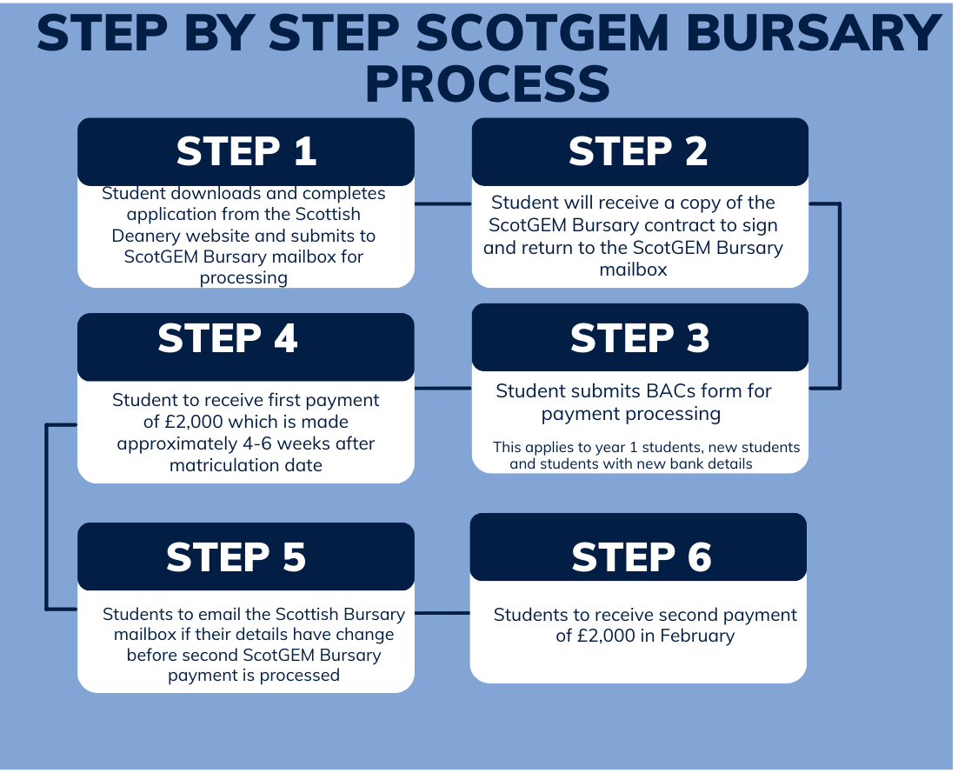

How are ScotGEM Bursary payments made?

Payment of the ScotGEM Bursary will be made via two instalments each of £2000 by BACS Direct Credit. Payments will be made approximately 4-6 weeks after matriculation date for the first payment and approximately 4 weeks after term commencement date for the second payment. Unfortunately due to a number of unpredictable factors around this process, we are unable to provide an exact payment date.

If any unforeseen circumstances arise which may result in the delay of ScotGEM Bursary payments, NES will communicate this to applicants as soon as possible.

How can I help to reduce delays in the Bursary administration process?
Using the same email address to apply every year will help us complete our verification checks.

Do I have to apply for the ScotGEM Bursary in order to get my tuition fees paid?

No, applicants do not have to sign up for a ScotGEM Bursary or sign a contract to receive their course fees. The return of service element is not in any way linked to the tuition fees process.

Will the ScotGEM Bursary affect the amount of student loan or any other grants I apply for?

The £4,000 ScotGEM Bursary has no impact on the funding for Scottish domiciled students. However, this may not be the case with other funding authorities in the UK. You should therefore check if the ScotGEM Bursary will have an impact on other funding support you may wish to receive.

Taking up the ScotGEM Bursary may affect your eligibility for university hardship funds. Therefore you should discuss this with the relevant University student finance team at an early stage.

Will I be eligible to claim the ScotGEM Bursary for any year of the course that I have to repeat?

We will give consideration to requests for students who need to repeat years, but the maximum ScotGEM Bursary payable to one student over the entirety of the ScotGEM MBChB course is £16,000.

What happens to the ScotGEM Bursary if I withdraw from my course?

Failure to be awarded an MBChB (graduation from course) means that you will no longer be complying with one of the conditions upon which the ScotGEM Bursary was awarded; this means you will need to repay the full amount of the ScotGEM Bursary you received, to the Scottish Government. NES will arrange repayment terms on an individual basis and while we may not require you to repay the whole amount in a lump sum, you will have to begin repayment within 3 months of leaving the programme.
Please refer to the ScotGEM Bursary repayment terms outlined above.

What are the conditions of the return of service with NHS Scotland?

If you take out the ScotGEM Bursary for the maximum of 4 years, then you must carry out a total of 4 years (or part-time equivalent) work as a doctor within NHS Scotland. If you only claim the ScotGEM Bursary for 3 years, 2 years or 1 year the return of service period will be 3 years, 2 years and 1 year respectively. The period of employment should begin within 12 months of graduation. For statutory leave occurring during this time (includes absences due to long term illness, maternity, paternity, or adoption leave), the duration of employment will be adjusted so that “the clock” is stopped during the period of absence.

What happens to the ScotGEM Bursary if I chose not to remain in Scotland for Foundation training, but I return for Speciality training?

You will be required to repay a proportion of your entire ScotGEM Bursary if you do not meet the conditions of the return of service period. If you do not work in Scotland for Foundation training, a repayment plan will initially be set up. However, should you return to Scotland for Specialty training, this would count towards 2 years of your service requirement as long as you can provide confirmation of your offer and evidence that you have taken up a post. If this happens, then your repayment amount would be adjusted accordingly.

What happens if an individual takes time out of training to work as a Clinical Teaching Fellow or Scottish Clinical Leadership Fellow? Would this count towards a return of service requirement?

Yes, if you are working within NHS Scotland this would count towards your service requirement.

What happens if an individual takes time out of training to work in a role not listed above?

Please contact us to discuss your situation at scotgembursary@nes.scot.nhs.uk.

What happens to the ScotGEM Bursary if I do not apply to work in NHS Scotland, fulfilling the return of service period post-graduation?

You will need to repay a proportion of/or your entire ScotGEM Bursary if you do not meet the conditions of the return of service period. The amount you repay will depend on how much of the return of service period you completed.

If you did not complete any of the return of service period, then you will have to repay the entire ScotGEM Bursary you received throughout the course. NES will arrange repayment terms on an individual basis and while NES may not require you to repay the whole amount in a lump sum you will have to begin repayment within 3 months of graduating. Please refer to the Bursary repayment terms outlined above.

If I apply for the ScotGEM Bursary, am I guaranteed a place in Foundation Training and Specialty Training in Scotland?

No, the application processes for both Foundation and Specialty training are competitive and not linked to the award of a ScotGEM Bursary.

Students in receipt of a Bursary are required to select Scotland as their first preference for Foundation Training. If you choose a Scottish Foundation Priority Placement or the Speciality Foundation Programme, then your first choice of Unit of Application (UoA) for the Foundation Programme should be the Scottish Foundation School.

For more information, please see link below:

https://foundationprogramme.nhs.uk/programmes/2-year-foundation-programme/ukfp/

What if I apply for Foundation training in Scotland and don’t get in?
If you apply to the Scottish Foundation School as your first choice and are not accepted, you will not be required to repay up to two years of the ScotGEM Bursary, depending on how long you were in receipt of a Bursary.
Please note that students in this situation who have received a total of 4 years of a Bursary will still need to apply for Specialty Training in Scotland if they wish to avoid repaying the final 2 years of the Bursary.
Can I apply to any Specialty Training programme in Scotland?
Yes, you can apply to any Specialty offered in Scotland which is appropriate.

For more information on Specialty training in Scotland, please see link below:

https://www.scotlanddeanery.nhs.scot/trainee-information/recruitment/

After Foundation training what if I apply to Specialty Training in Scotland and don’t get accepted?
There is no need for Bursary repayment as long as you apply for Foundation training in Scotland (first choice) and accept and enter a post if offered and apply and enter Specialty training in Scotland.

What if I cannot meet the return of service period due to special circumstances?

There is scope to extend the return of service period to equate to the number of years required service if there are any special circumstances. Examples could include long term illness, maternity leave and other forms of statutory leave.
NES will consider every case on its own merits and will advise as necessary.

Returning to full time Higher Education part way through your return of service period, will not usually be considered a special circumstance.

Details of the special circumstances process can be found here.

What if an individual defaults on repayment?

NES has standard processes in place to recoup unpaid Bursary money. NES will provide full details to the Scottish Government on any defaulted payments. NES is also likely to notify the GMC as the regulatory body for doctors in the UK, to determine whether this action represents a professional probity issue.

Appendix 1: Graduate entry medicine programme return of service bursary: terms and conditions 2024/25 from Scottish Government

Definitions and Interpretation

In these Conditions, the words and expressions set out in the Schedule have the meanings ascribed to them in that Schedule.

In these Conditions unless the context otherwise requires, words denoting the singular shall include the plural and vice versa and words denoting any gender shall include all genders.

The headings in these Conditions are for convenience only and shall not be read as forming part of the Conditions or taken into account in their interpretation.

Except as otherwise provided in these Conditions, any reference to a clause, paragraph, sub-paragraph or schedule shall be a reference to a clause, paragraph, subparagraph or schedule of these Conditions. The Schedules are intended to be contractual in nature. They form part of the Agreement and should be construed accordingly.

This Agreement may only be varied by written agreement signed by both parties.

Purposes of the Bursary

2.1 The Bursary is made to enable the Student to carry out a Graduate Entry Medicine (ScotGEM) Primary Medical Qualification degree course (“the MBChB”) at the University of Dundee and St Andrews.

2.2 No part of the Bursary shall be used to fund any activity or material which is party political in intention, use, or presentation or appears to be designed to affect support for a political party.

Payment of Bursary

Payment of the Bursary is subject to receipt of the completed application form from the Student for the relevant academic year. Payment will only be made to those applicants who the Scottish Ministers deem are eligible for the Bursary. The Bursary shall be paid by the Scottish Ministers to NHS Education for Scotland (NES), who will pay the Student.

Payment of the Bursary to the student will be made via two instalments each of £2000 STERLING.

If any tax is deemed payable on the Bursary it will be the Student’s responsibility to make any required tax payment to Her Majesty’s Revenue and Customs.

Conditions of Bursary

Payment of Bursary is subject to compliance by the Student with all of the following conditions.

The Student must be registered on the Scottish Graduate Entry Medicine (ScotGEM) primary medical qualification.

In the event that a year of study requires to be repeated there is no guarantee that any further funding will be made available to the Student. A student may apply for a maximum of four Bursaries irrespective of the number of years taken to complete the ScotGEM programme.

The Student must complete the MBChB. Failure to be awarded an MBChB will result in the Student being required to repay to the Scottish Ministers the full amount of each Bursary received by the Student in connection with ScotGEM starting repayment within 3 months of failing to complete the MBChB.

Post completion of the MBChB, within the timescale referred to in clause 4.7 below, the Student must apply for, as appropriate, Foundation Training, specialty training or other work as a doctor, ranking Scotland as their first preference in the application process, thereafter committing and completing a period of 12 months of work in medicine in any area of NHS Scotland for each year in which the Student received the Bursary. Any doctor who fails to complete their Foundation Training in Scotland must select Scotland as their first choice for all applications for specialty training.

The Student must notify NES of their intention to work part-time during the time period of the agreed commitment. The Student must serve the equivalent of twelve full-time reckonable months as a doctor in NHS Scotland for each Bursary received.

The commitment period of work must begin within 12 months of the date of graduation from the MBChB course and run as a continuous period of employment. For any doctor who fails to complete their Foundation Training in Scotland the commitment period of work must begin within 8 months of completion of Foundation Training.

The Student undertakes to provide as soon as reasonably practical to NES the name and address of their employer where they work and any changes to this information until the agreed commitment has been completed.

Failure to meet these requirements will be treated as a breach of the Bursary conditions. Voluntary failure to meet the agreed commitment will be treated as a breach and the full Bursary funds received by the Student for the commitment period, or a pro rata share, must be repaid to the Scottish Ministers.

Confidentiality and Data Protection

All information submitted to the Scottish Ministers may need to be disclosed and/or published by the Scottish Ministers. Without prejudice to the foregoing generality, the Scottish Ministers may disclose information in compliance with the Freedom of Information (Scotland) Act 2002, any other law, or, as a consequence of judicial order, or order by any court or tribunal with the authority to order disclosure. Further, the Scottish Ministers may also disclose all information submitted to them to the Scottish or United Kingdom Parliament or any other department, office or agency of Her Majesty’s Government in Scotland, in right of the Scottish Administration or the United Kingdom, and their servants or agents. When disclosing such information to either the Scottish Parliament or the United Kingdom Parliament it is recognised and agreed by both parties that the Scottish Ministers shall if they see fit disclose such information but are unable to impose any restriction upon the information that it provides to Members of the Scottish Parliament, or Members of the United Kingdom Parliament; such disclosure shall not be treated as a breach of this agreement.

For the purposes of administering the Bursary, the Scottish Ministers are the data controller and will comply with the Data Protection Laws and other relevant legislation. The Student acknowledges and agrees that the Scottish Ministers may use the information (including the Student’s personal data) provided by the Student in connection with the Bursary for all purposes related to Bursary administration. The Student further agrees that the Scottish Ministers may share the Student’s information with the University at which the Student undertakes the MBChB, the NHS Education for Scotland (NES) and with the Student Awards Agency Scotland for the purposes of Bursary administration.

Recovery etc. of Bursary

The Scottish Ministers may re-assess, vary, make a deduction from, withhold, or require immediate repayment of the Bursary or any part of it in the event that the Student fails to comply with the Conditions of Bursary, in particular as set out in Clause 4.

Notwithstanding the provisions of this clause 6, in the event that the Student is in breach of any of the Conditions, the Scottish Ministers may, provided that the breach is capable of a remedy, postpone the exercise of their rights to recover any sum from the Student in terms of clause 9 for such period as they see fit, and may give written notice to the Student requiring him or her to remedy the breach within such period as may be specified in the notice. In the event of the Student failing to remedy the breach within the period specified, the Student shall be bound to pay the sum to the Scottish Ministers in accordance with the foregoing provisions.

Any failure, omission, or delay by the Scottish Ministers in exercising any right or remedy to which they are entitled by virtue of clauses 6.1.to 6.2 shall not be construed as a waiver of such right or remedy.

Assignation

The Student shall not be entitled to assign, or otherwise transfer its rights or obligations under the Agreement.

Continuation of Conditions

The conditions set out in this contract, except for clause 6, shall continue to apply for a period of 5 years after the end of the last month in which the work commitment referred to in clause 4 (as applicable) has been completed.

Clause 6 shall continue to apply until the end of the period referred to in that clause.

Governing Law

This contract is governed by the Law of Scotland and the parties hereby prorogate to the exclusive jurisdiction of the Scottish Courts.

If you wish to accept the offer of this Bursary on the whole terms and conditions as set out in the letter and annexed Schedule, you should sign and date both copies of the Bursary Acceptance below and return one copy of the offer of a Bursary to NES, together with your completed application form and any supporting evidence. You should retain the second copy of the offer of a Bursary and Schedules for your own records.

