Course Booking Guide – Entry Level Courses
PUBLIC HEALTH CONSULTANTS ONLY

As a Public Health Consultant, you will need to create an account on the NES Portal.

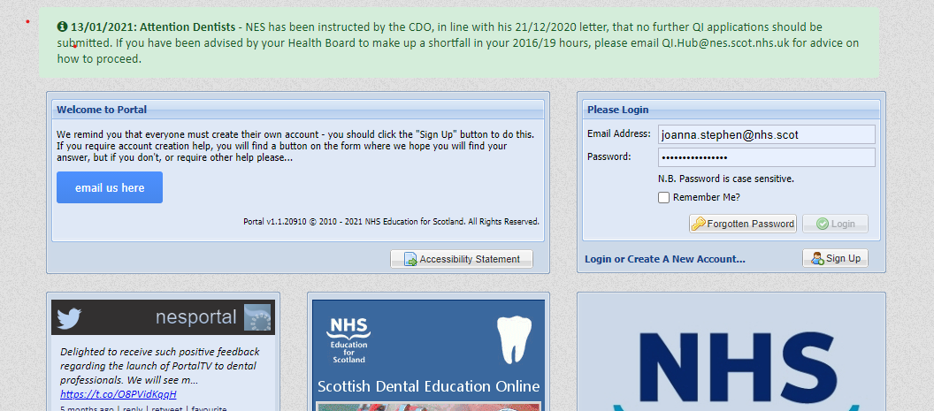
Click Sign Up

Click on Sign Up and complete the form to create an account. Please select ‘Other Public Sector Employee’ in the Health Board Section, Medical Consultant and then enter the numeric part of your registration number.

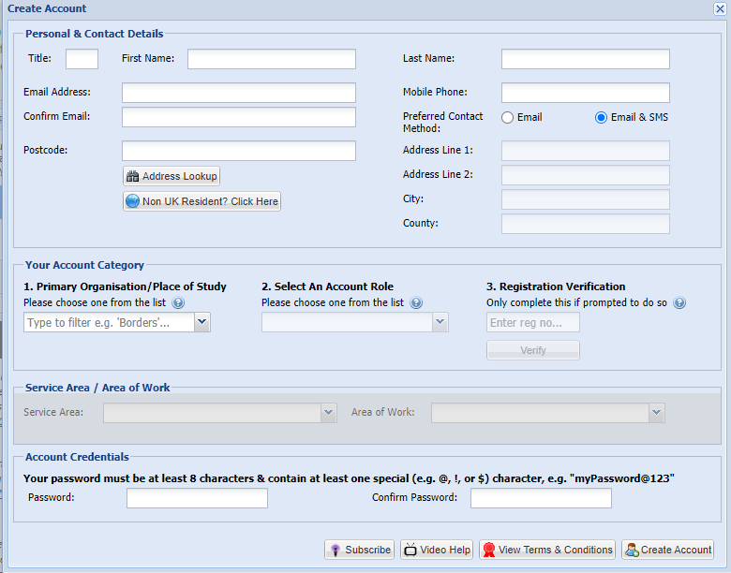
Enter numeric part of your Public Health number

Once you have registered you will be able to book a place on the course, or if the course is already full, add your name to the waiting list. You will be emailed when a space becomes available and when more dates are available.

When booking, you should add your chosen course to the “basket”, click “manage your basket” and then follow the onscreen instructions to check-out/complete the booking process.
If at any stage, you have problems with the registration if you contact the Portal Help Desk and they will be able to resolve this for you.
If you have any course related queries, please contact the FDA Admin team at FDA.Admin@nes.scot.nhs.uk

Update to Public Health Guidelines on the website. Options they need to select are Other Public Sector Employee in the Health Board Section. Medical Consultant and then the numeric part of their registration number.

