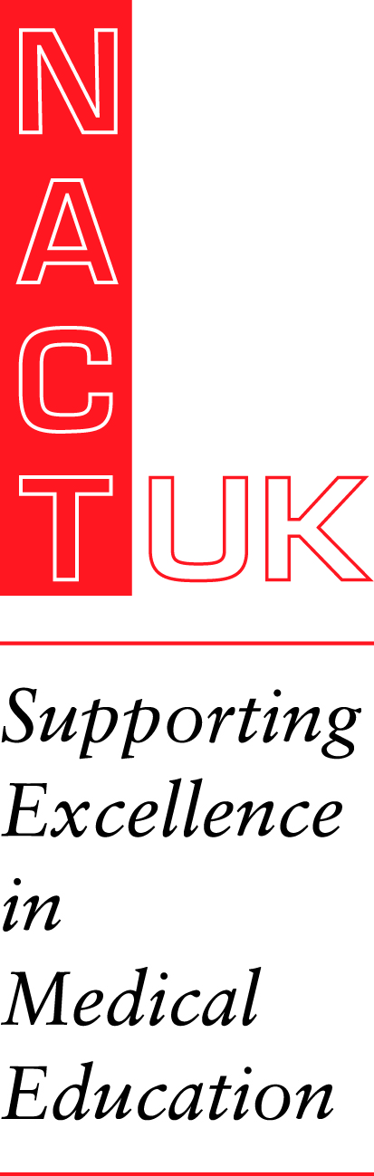 | Your Future in Medical Education Meeting  Tuesday 14 June 2022  10.00am – 4.00pm  Macdonald Burlington Hotel, New Street, Birmingham
This form will be held by NACT UK for one year, and then disposed of securely in accordance with the new General Data
Protection Regulations and our privacy policy details of which can be found on our website.
By signing here you agree to the above ………………………………………………………

Title  (Dr, Mr(s)): |  |  | First name:
Surname:
Address for contact:
Telephone |  |  |  | Email
Job Title
Please specify any dietary requirements:

Registration fee including lunch and refreshments is:
Non-Members £150.00 (inc VAT)
Members £100.00 (inc VAT)
Trainee’s non-members to include Associate Membership £135.00 (inc VAT)

◻ | Payment by BACS: HSBC, 117 Great Portland Street, London W1A 4UY.  Please quote Name as reference. Account #: 31221809 sort code: 40-03-15
◻ | Please invoice to:
 | Invoice Address:

Please return this form: NACT UK, L15 Bletchley Business Campus, 1-9 Barton Road, Bletchley, MK2 3HU or office@nact.org.uk. No refunds for cancellation within 5 working days of the course start date

