Course Booking Guide – Entry Level Courses

- Go to the FDA IT Platform (Knowledge Network) – www.fda.nes.scot.nhs.uk

- In the grey box, enter your GMC/GDC number, your email address and press “Register”
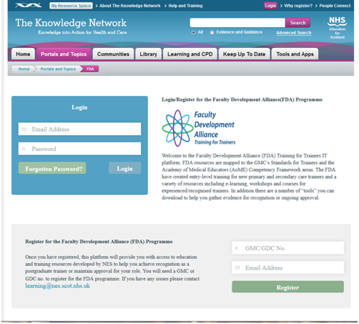

- When asked, enter the following details:
Name
Role
Specialty
Hospital

- Create a password (this can be changed later)
- Once the registration is complete, you will be taken to the programme page
- Click on the “Entry-level Resources” menu option (this will list all the FDA resources currently available).
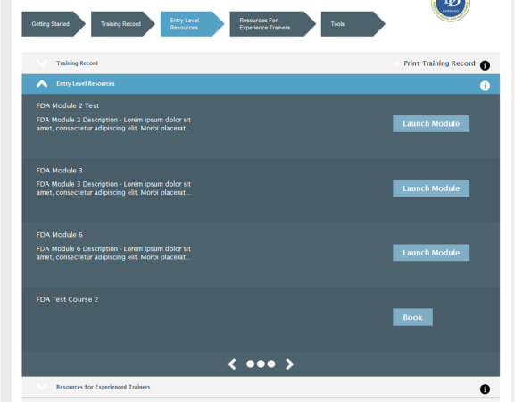

Please also note the Training Record menu option. This is where you will find your attendance certificate after the course.

- Under the “Entry-level Resources” tab, scroll to find the workshop/date required and press “book”.

You will now be directed to the Portal website – www.Portal.scot.nhs.uk – where you will be asked to create a Portal account if you do not already have one (you must use the same email address for both accounts) – and will then be able to book a place on the course (or if the course is already full, add your name to the waiting list).

When booking, you should add your chosen course to the “basket”, click “manage your basket” and then follow the onscreen instructions to check-out/complete the booking process.

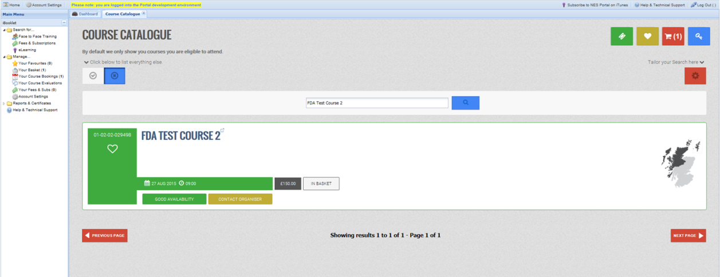

- Once your place is booked, you can log out.

Updated 21/10/2021

