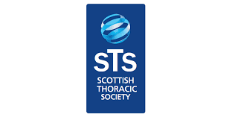

Scottish Taster Course in Respiratory Medicine
Wednesday 6th October 2021

Time | Topic | Speaker
0930-1000 | Registration and Introduction
Session 1 | General Introduction | Dr Manjit Cartlidge
10.05-10.30 | Why Respiratory Medicine?  - The Consultant view  - The Trainee view | Professor Hill  Dr Eleanor Hampton
10.30-10.50 | The application process  - The Consultant View  - The Trainee View | Dr James Tiernan  Dr Fiona North
10.50-11.10 | Being an ST in Respiratory Medicine | Dr Manjit Cartlidge
11.10-11.30 | Coffee Break
Session 2 | Workshops
11.30-12.00 | Workshop 1: Bronchoscopy/EBUS | Dr Adam Marshall
12.00-12.30 | Workshop 2: Research: Lab vs Clinical | Dr Ahsan Akram,  Dr Erin Gaughan/ Dr Susan Fernandes
12.30-13.30 | Lunch
Session 3 | Workshops
13.30-14.00 | Workshop 3: Thoracic Ultrasound | Dr Geoff Martin
14.00-14.30 | Workshop 4: Pleural procedures | Dr Mahendran Chetty
14.30-15.00 | Coffee break
Session 4 | Why I like to specialise in:
15.00-15.15 | Airways disease | Dr Gourab Choudhury
15.15-15.30 | Interstitial Lung disease | Dr Owen Dempsey
15.30-15.45 | Lung cancer | Dr John MacLay
15.45-16.00 | Pulmonary infection | Dr Simon Finch
 | Closing Remarks
 | Networking and drinks reception (if not online)

