Appendix F – Engaging with the Team and Managing Change

Taking Stock and Engaging with the Team
During the course of the pandemic Health Boards, in collaboration with practices, have been using a “tier” system with some enhanced and other services placed on “pause” at times during the year (refer to PCA(M)2020)02).
As the vaccination programme rolls out across the country and mitigation of risk changes, practices will need to consider how they return to the provision of normal services or “business as usual”.
The SWOT method:
Now may be a good time to reflect with the team on the successes of the last year and to consider those things that didn’t work so well. Conducting a team SWOT (strengths, weaknesses, opportunities and threats/challenges) analysis (see template below) on the various functions of the practice may be a good way to start.
It may sound simplistic but can be a good way to open up discussions and debate with the whole team on the future direction of the business. There is opportunity from every crisis and the learning from the last year could be harnessed from the team as you move forward.

Example - Andy Vickerstaff, Practice Manager in Aultbea & Gairloch Medical Practice, provides a good example of team review:
They held a practice team session " trying to take some time out to wrap wet towels round our heads to think about some longer-term issues, other than the day to day challenges.

Here are some of the agenda points we used that might be helpful to others:

Ice breaker - what are the best things about being a GP? What are 5 things you love about your job
- Myers Briggs Type Indicator - simple questionnaire and then compare answers. We have 2 relatively new partners so used this to learn more about what makes each of us "tick"
- SWOT analysis of the practice
- What is our long- term goal? (i.e. do we all agree!)
- Revisit our 5 year plan - we decided not to give this much time given so much uncertainty at the moment!
- Post Covid-19 restart plan
- We then went on to review some internal items such as functional responsibilities, partnership agreement, premises, outside commitments.”

t

Reflection and Collective Thinking Method:
Example provided by Pauline Hutton, Practice Manager at the Pentlands Medical Centre who found space to reflect collectively to understand how they had responded during the pandemic crisis and how they could now move forward (see Appendix G).
The Questioning Approach:
The following questions may help the team focus on how they continue to develop services to meet patient needs. .
During the Covid-19 Pandemic, usual working practices have changed but some
of these changes could be improvements to be harnessed for the future

Users – patient and staff experiences and feedback | What feedback are you getting from patients, carers, and service users?  What are your staff saying about how new way of working are affecting them?  Have you strengthened relationships with other teams or organisations including the third sector?
Effectiveness | How have patients, staff, clinical or other outcomes been impacted (referral rates, long term conditions and enhanced services for example)?
Sustainability | Have changes resulted in less impact on the eniviroment through less patient travel, for example?
Safety | Have their been any errors?  Have actions resulted in either any harm, potential harm or improved safety?
Equity | What has been the impact on under-represented groups or those unable to use technology?  How effectively have you been able to manage these risks?
Efficiency | Are your new processes or pathways faster?  Have you been able to accommodate more or less people?  Is your team now working efficiently or do you still need to improve your processes?

There are no prescriptive ways of planning the direction of travel but engagement with your patients, the wider primary care team and your Health Board or HSHP will be important over the next year or two, together with enagement with the third sector.

Managing Change and Re-design – a starting point

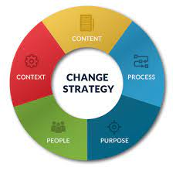

The last year has effectively been about managing change and whilst managing change is primarily concerned with managing the conversations between those implementing the change, managing the service and undertaking the workload, it is also about managing the emotions and expectations of those working in and using the service. Therefore, engagement and communication are key to success.
Many people struggle with change – as much as 90% of us don’t like change for many reasons but principally because:
- People fear being different particularly when there is no precedent
- People feel overwhelmed and stressed
- People fear departing from the status quo
- People lack trust in the ones making the changes
- People know that change brings both possibilities and problems

Or another way of looking at how people respond to change is the “change curve” and how, as the implementer of change, you can respond at different times and in different ways to get the best out of the people involved. If you have an appreciation of how people tend to react, then you can introduce mitigation measures along the way to improve the outcome and you won’t be surprised or taken aback by the behaviours.
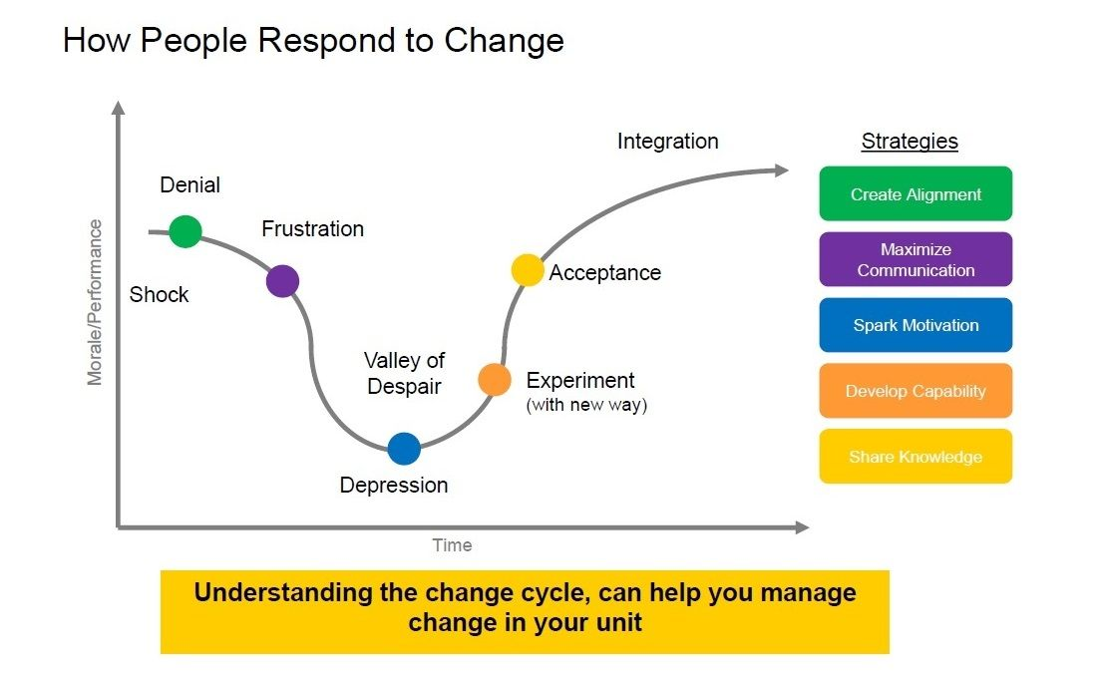

When considering how you might implement change or imbed the changes you have made over the last year so they become the norm, you might want to consider the 7 step approach to change as outlined below and how, in turn, this is communicated with those who are most affected by the change – the staff, patients and their carers.
The REASONS for the change
The RISKS of the change
The RESOURCES that are required
Who RAISED the need for the change in the first place
The expected RETURN from implementing the change
Who is ultimately RESPONSIBLE for the change
The RELATIONSHIP between changes

Readiness Checklist
To help practices begin the planning process for their future direction, a readiness checklist is available on the NES website here and can be adapted to meet the needs of the practice.
Turas Learn has some additional learning on managing change both at an organisational and personal level and Appendix D provides further information on setting up a Turas Learn Account.

