Virtual QM Visits Guidance
An on-site visit bundle currently comprises of:
Pre-visit activities:
  - Visit Notification
  - PVQ (trainee)
  - PVQ (trainer) (being piloted)
  - VPP
  - PVTC
Visit activities:
A single visit time- table up to full-day
Sessions with:
- Site leads, clinical / non-clinical management / DME
- Trainers - typically 30-60min
- FYs (separate or combined with others) - typically up to 1hr
- GPSTs (separate or combined with others) - typically up to 1hr
- IMs (separate or combined with others) - typically up to 1hr
- STs (separate or combined with others) - typically up to 1hr
- Nurses / AHPs / Others– typically 30min
- Feedback preparation session -typically 30min
- Feedback session – typically 30min

Post-visit activities:
    - Report writing
    - Post-writing – factual accuracy, action plan & report publication

Principles for virtual QM visits
- Using MS Teams (unless local IT is unable to support Teams, use of Skype for business or Goto for meetings should be considered).
- Question sets do not need to be rewritten but their use needs to be managed and tailored to the needs of each visit, informed by PVQ and confirmed by Visit Lead at PVTC in order that panel members are aware of what is required of them in the visit.
- Ahead of a visit a test run with the site should be conducted to ensure local technology in room booked for the visit works appropriately.
- If the number of trainees due to attend a session is above 10, the chair should consider splitting the session into 2 separate sessions.
- If the session consists of mixed grades attending the same session, the visit lead should consider extending the session time (up to 90 mins).
- Links to visits should be set up with a nominated lead person for managing entry to each visit session (either QIM or QIA).

Pre-visit activities:
- Visit lead (informed by QIM) will confirm the approach to visit and number of days (1 -3) that it will take.
- Following the agreement of the approach to the visit, QIM should notify the DME of intention to visit (if the visit is more than 1 day) ahead of the official notification being issued.
- Notification modification reflecting mode of visit activity (see below) –
- PVQ (trainee)
- PVQ (trainer)
- VPP
- Pre- PVTC meeting between QIM and Visit Lead
PVTC:
- A discussion or meeting should take place between QIM & Visit Lead prior to the pre-visit teleconference, this will be in order to discuss and agree what the focus areas of the visit will be (guided by the PVQ and the rest of the information provided in VPP). This will ensure that these areas are clear to be then confirmed with the rest of the visit panel at the PVTC.
- The PVTC should also now take place using Microsoft Teams. QIM/QIA should ensure that all panel members are sent teams invite and the Teams etiquette guide is distributed, to ensure all panel members are aware of how to participate.
- The PVTC now requires detailed management of the use of the question sets – identifying where the trainee PVQ provides enough information for the report – and those areas that require question sets to be used. The Visit Lead during the PVTC must confirm which areas of the question sets that will be covered on the visit day(s) and ensure that each panel member is aware of their responsibilities and specific question areas.
- For revisits - the questions to be used should major on the previously noted concerns and requirements.
- Visit Lead should remind panel members that a business dress-code should be adhered to by all panel members when conducting virtual visits.

Visit activities:
A visit could be conducted in a full-day or split over up to 3 separate sessions (if so, closely linked in time and within the week of initial date), as mentioned above this should be decided by the Visit Lead through informed discussion with QIM. For virtual visits it is suggested that the session for Nurses / AHPs is now dropped. Scheduled break times between each session should be included in each timetable. There is also the opportunity to include recent, past cohorts of trainees in the pre-visit questionnaire and indeed the visit (if training numbers are low or if visit date has followed a recent changeover date).
Option 1, 2 and 3:
- 1 session Full-day model with sessions for:
- Site leads, clinical / non-clinical management / DME, then
- Trainers - typically 30-60min, then
- FYs (separate or combined with others) - typically up to 1hr, then
- GPSTs (separate or combined with others) - typically up to 1hr, then
- IMs (separate or combined with others) - typically up to 1hr, then
- STs (separate or combined with others) - typically up to 1hr, then
- Feedback preparation session – typically 30min
- Feedback session – typically 30min
Example of full-day timetable:
Hospital A | Duration (minutes) | Activity
08.30 |  | Visit Panel Convenes
08.40 – 09.10 | 30 | Meeting with DME/ Clinical lead – overview of training environment
09.10 – 09.20 | 10 | Break
09.20 – 10.20 | 60 | Visit team meets with trainers
10.20 – 10.30 | 10 | Break
10.30 – 11.30 | 60 | Visit team meet foundation trainees
11.30 – 11.40 | 10 | Break
11.40 – 12:40 | 60 | Visit team meets GPST trainees
12.40 - 13.10 | 30 | Lunch
13.10 – 14.10 | 60 | Visit team meets Core/IMT/IST trainees
14.10 – 14.20 | 10 | Break
14.20 – 15.20 | 60 | Visit team meets ST3+
15.20 – 15.50 | 30 | Panel discussion & agreement for feedback session
15.50 – 16:20 | 30 | Feedback session
16.20 |  | Close

- 3 session model (over 1.5 days):
Up to 3 separate sessions (the session with Site leads could be on same day as PVTC) – with as many of visit panel in on each session as possible with at least Panel Chair, QIM and Lay being present in all). If trainees’ sessions are split (whether as described or some other variant) the gap between should be minimised as there is a risk that chatter between sessions could alter messages shared).

Session 1: Site leads, clinical / non-clinical management / DME, then
Trainers - typically 30-60min.
Session 2: FYs (separate or combined with others) - typically up to 1hr, then
GPSTs (separate or combined with others) - typically up to 1hr.
Session 3: IMs (separate or combined with others) - typically up to 1hr, then
STs (separate or combined with others) - typically up to 1hr,
then Feedback session – typically 30min
Session 1 (day 1 am or pm):
Hospital A | Duration (minutes) | Activity
09.30 |  | Visit Panel Convenes/internal briefing
09.40 – 10.10 | 30 | Pre-visit teleconference with visit panel  (Decision on questions and question allocations)
10.10 – 10.25 | 15 | Break
10.25 – 11.25 | 60 | Meeting with Service Leads and Management
11.25 – 11.40 | 15 | Break
11.40 – 12.40 | 60 | Visit team meets with Trainers
Close of Day 1

Session 2 (day 2 am) & Session 3 (day 2 pm):
Hospital A | Duration (minutes) | Activity
09.30 – 9.40 | 10 | Visit Panel Convenes/internal briefing
09.40 – 10.40 | 60 | Visit panel meets with FY Trainees
10.40 – 10.55 | 15 | Break
10.55 – 11.55 | 60 | Visit panel meets with GPST Trainees
11.55 – 12.40 | 45 | Lunch
12.40 – 1.40 | 60 | Visit team meets with Core/IMT/IST Trainees
14.10 – 14.25 | 15 | Break
14.25 – 15.25 | 60 | Visit team meets ST3+
15.25 – 15.55 | 30 | Panel discussion & agreement for feedback session
15.55 – 16:25 | 30 | Feedback session
16.25 |  | Close

- 2-session parallel model which could be configured as follows:
Session 1:
Site leads, clinical / non-clinical management / DME, then
Trainers - typically 30-60min
Session 2 running concurrent parallel sessions:
Half of visit panel with
- FYs (separate or combined with others) - typically up to 1hr, then
- GPSTs (separate or combined with others) - typically up to 1hr
Led by Visit Lead (must be APGD for Quality) and include Quality Improvement Manager
Other half of panel with:
Must be led by APGD for Quality and include Quality Improvement Manager
- IMs (separate or combined with others) - typically up to 1hr
- STs (separate or combined with others) - typically up to 1hr
then
Both halves of panel coming together for feedback preparation session – typically 30min
The parallel session model requires Panel chair and experienced APGD-Q to lead the parallel sessions, possibly 2 QIMs, possibly 2 QIAs. Only 1 lay person required for whole visit.
The parallel session model requires MS Teams with breakout room functionality or workaround to achieve same.
Voting or other functionality is desirable.
Session 1:
Hospital A | Duration (minutes) | Activity | Panel 1 | Panel 2
09.30 |  | Visit Panel Convenes/internal briefing | Both panels together
09.40 – 10.10 | 30 | Pre-visit teleconference with visit panel  (Decision on questions and question allocations) | Both panels together
10.10 – 10.25 | 15 | Break
10.25 – 11.25 | 60 | Meeting with Service Leads and Management | Both panels together
11.25 – 11.40 | 15 | Break
11.40 – 12.40 | 60 | Visit team meets with Trainers | Both panels together
Close

Session 2 parallel sessions:
Hospital A | Duration (minutes) | Activity | Panel 1 | Panel 2
09.30 – 9.40 | 10 | Visit Panel Convenes/internal briefing | Both panels together
09.40 – 10.40 | 60 | Panels split for trainee session | Panel meets with FY Trainees | Panel meets with GPST Trainees
10.40 – 10.55 | 15 | Break
10.55 – 11.55 | 60 | Visit panel meets with GPST Trainees | Panel meets with Core/IMT/IST Trainees | Panel Meets with ST Trainees
11.55 – 12.25 | 30 | Lunch
12.25 – 12.55 | 30 | Panel 1 and 2 discussion and preparation for feedback | Both panels together
12.55 – 1.25 | 30 | Feedback session | Both panels together, feedback delivered by Visit Lead.
1.25 Close

Sending visit notification:
Once the timetable has been established and visit notification drafted, the QIA/QIM should create the team’s sessions links, all the links should be sent to the Director of Medical Education using appendix 1.
Trainee and trainer invite to visits:
As we will send the invites to virtual visits, the QIM/QIA will generate the visit links for teams meeting (separate links for each cohort of trainees and trainers) and send the meeting requests to them using the template in appendix 2. You should ensure that you once you create the meeting link that you click the meeting options link using the guidance below and select “only me” from the who can bypass the lobby section, this will allow the nominated panel member (either QIM or QIA) to manage entry to each session. This will ensure that each person invited to a meeting can’t join a meeting until they are admitted from the lobby.

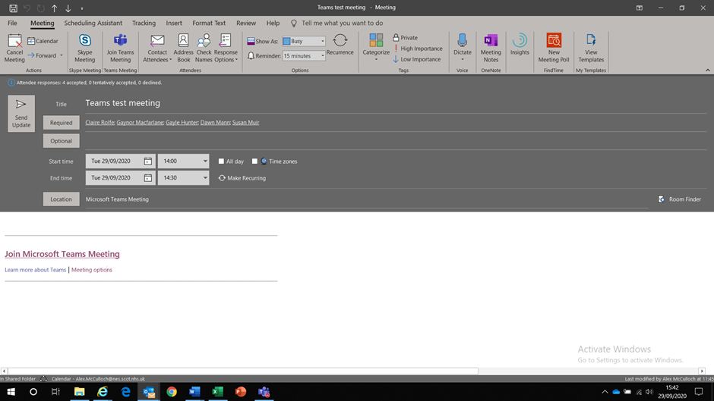

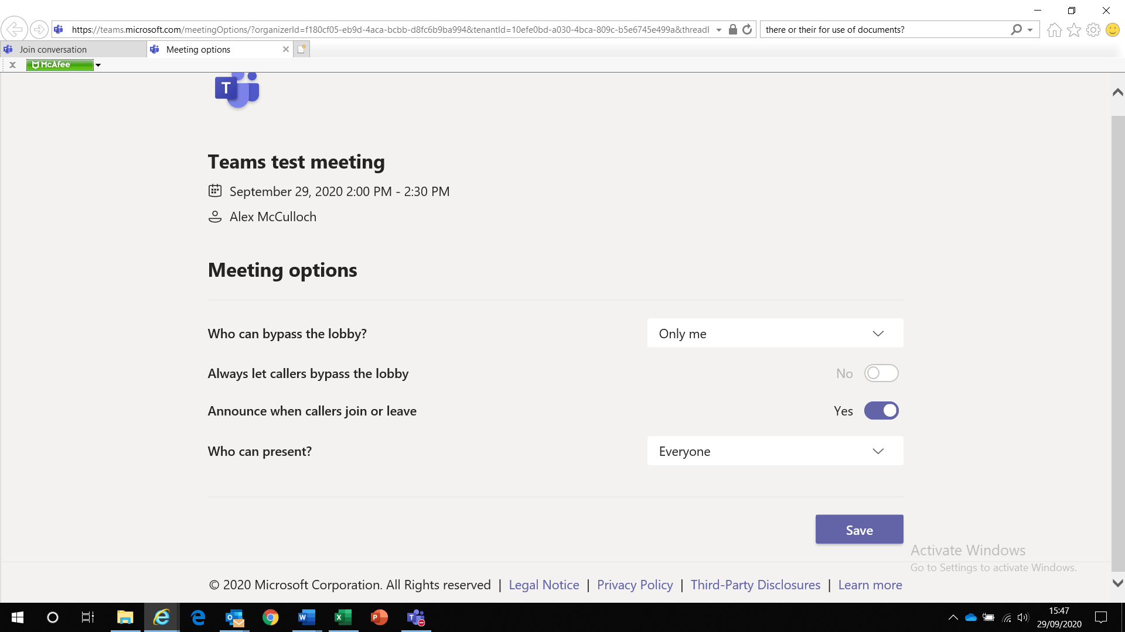

Once we have confirmation of the trainees and trainers who will be attending the visit, the QIA/QIM should check there are no additional attendees that are missed off the original list and any missed off the initial list should be sent the link.
Sample trainee e-mail appendix 2.
Sample trainer e-mail appendix 3.
Panel member invites:
Following the distribution of the invites to the visit, QIM/QIA should also make contact with the visit panel to confirm the details of the visit and PVTC, using the invite in appendix 4.

Use of question sets for note taking during visits:
As there will be no longer a need for hard copies of the visit question sets to be issued for note taking, we have created shortened electronic versions for information purposes which should be issued to panel members as previously done and with the guidance that they are free to print these documents themselves to use them for note taking purposes. We also need to remind them that any notes they do produce (either in hard copy or in the electronic copy) should be deleted once the panel have reviewed the final version of the visit report.
Trainee Question List
Trainer Question List

Appendix 1:
Dear DME,
Please find attached a deanery visit notification in regard to our triggered/scheduled visit to specialty at hospital that will take place on date (s).
To support this visit we would be grateful if you would arrange the following:
- Confirm receipt of the visit notification and of visit date(s) with deanery Quality Improvement Manager/Administrator.
- Confirm visit date with local trainers, trainees and management. We will inform both the trainees and the trainers directly and send links to join their appropriate sessions but would ask that you also distribute the timetable with the appropriate links to join the teams sessions to them.
- Book appropriate on site room with access made available to Microsoft teams for all sessions during the visit (please ensure that the visit room is a private space away from the clinical environment and is set out for use in line with government guidelines to allow social distancing to be implemented.
- Conduct test of equipment in booked room with deanery Quality Improvement Manager, testing MS teams link to ensure it works appropriately. If local software is Microsoft Windows 7 or older, this may not be compatible with Microsoft Teams and alternative software such as Skype or Goto may need to be considered.
- During the visit sessions ensure that only the cohort who are due to speak to the visit panel are present in the visit room at that time.
- Ensure that you send the trainers names and contact details to deanery Quality Improvement Manager by date specified on the notification form (usually one week from date you are sent the notification form). These contacts are vitally important to the process and will be used to send the trainers the pre-visit questionnaire and their visit invite.
- Deanery visit notification is returned with all requested documentation included by date specified on form.
- Included in visit notification the contact details of medical education/nominated site person and named trainee/trainer representatives for each session.
- Provide an on-site a contact person for the deanery to liaise with on the day of the visit, this is to ensure we can contact them in case we are alerted to any difficulties by any of the visited cohorts throughout the day(s).
- On site contact person monitors the different cohorts entry/exit to visit room throughout the day(s) to minimize interruption to the sessions.
- On site contact person monitors room capacity on day of visit to ensure room does not exceed capacity according to social distancing guidelines.
Included below are the links that you require to access the virtual teams sessions that will take place throughout the day(s). As mentioned above, each cohort of trainees participating in the visit will be sent the links to their sessions separately and can either choose to participate in the visit by attending at the on-site room or from home.
On the visit days, the attendees will be asked not to disclose any information in regard to what is said in each session out with the room to anyone else (this is particularly important when a visit is over multiple days), we would ask that you endorse this message with the department being visited and ensure that everyone being visited is aware of this.
Included below is a short teams etiquette guide to ensure that participants are aware of how to participate in discussions.
Thank you for your support in helping us arrange this visit.
Professor Alastair McLellan and Professor Adam Hill
Lead Dean Directors for Quality
Day 1:
09:30 – 10.00 | Pre-visit teleconference with visit panel  (Decision on questions and question allocations) | 30 mins
10:15 – 11.15 | Meeting with Service Leads and Management | 30- 60 mins | Join Microsoft Teams Meeting
11:15 – 11:30 | Comfort break | 15 mins
11: 30 – 12:30 | Visit team meets with trainers | 60 mins | Join Microsoft Teams Meeting
Day 2:
09:30 – 09.50 | Panel meet for internal briefing | 20 mins
10:15 – 11:15 | Visit team meets Foundation Trainees | 60 mins | Join Microsoft Teams Meeting
9:50 – 10:05 | Comfort break | 15 mins
10.05 - 11.05 | Visit team meets with GPST Trainees | 60 mins | Join Microsoft Teams Meeting
11.05 – 11.15 | Comfort break | 15 mins
11.15 – 12.15 | Visit team meets with Core/IMT/IST/CMT Trainees | 60 mins | Join Microsoft Teams Meeting
12.15 - 13.00 | Lunch | 45 mins
13.00 – 14.00 | Visit team meets with ST Trainees | 60 mins | Join Microsoft Teams Meeting
14.00 – 14.45 | Panel discussion and preparation for feedback | 45 mins
14.45 – 15.15 | Feedback to DMEs and service leads | 30 mins | Join Microsoft Teams Meeting

Appendix 2:
Dear trainee,
The deanery will be conducting a enter triggered/scheduled virtual Quality Management visit to hospital on date/time. This visit is being conducted due to the following reasons:

We will be meeting with:

About Deanery Quality Management Visits:
Quality management visits are a key element of the work undertaken by the NES Quality Management Team. Such visits enable NES to make an assessment regarding the quality of a training environment provided by local education providers (LEPs) or within a particular training programme, and specifically whether training satisfactorily meets the GMC's Standards for Medical Education and Training.
Quality management visits are NOT an assessment of individual trainees or their competencies. The visit panel wants to hear and acknowledge YOUR experiences of training, both good and bad to identify and promote areas of good practice as well as support the introduction of measures to develop and improve training. All trainee views are taken into account by the panel, irrespective of training programme or stage of training. As a trainee your role in the visit process is crucial and we encourage you to make every effort to attend. Your department or local postgraduate education centre should make arrangements to free you from clinical duties and enable you to attend for the visit. Further information in relation to deanery visits can be found here:
https://www.scotlanddeanery.nhs.scot/trainee-information/quality-management-visits/
What’s different about a virtual visit conducted using Microsoft teams:

- You will be sent a link to join your session which is imbedded below.
- You can either give your opinion vocally (when invited to do so by Visit Lead) or by using the chat function. Further information is in the imbedded Microsoft Teams guide below.
- You have the option of joining the visit from the room provided for its use in the hospital you are working in or by accessing the link from home or wherever you feel most to do so.
- Please confirm you will be attending the visit by responding to the invite you are sent and by informing our team where/how you will join (this is to ensure we are aware of the numbers of trainees we should expect to meet with for each session).
- The record function which is available on Microsoft Teams will not be used to record any deanery visit sessions.
What remains the same about deanery visits?
- You will be free to share your opinions without any comments being attributed to you personally in the finalised version of the deanery visit report.
- Deanery visit reports are finalised within a 6 - week period.
- Deanery visit reports will be published on the Scotland Deanery website, within 3 months of the visit date and can be found here: https://www.scotlanddeanery.nhs.scot/quality/specialty-visit-reports/

As you are an FY/GPST/IMT/IST/ST trainee we are inviting you to attend the FY/GPST/IMT/IST/ST session at time and provide your views on the training provided to you in this department.

As the visit will be conducted via Microsoft teams, you can access the meeting by clicking the join meeting link below:
Enter Join Microsoft Teams Meeting link.
A short guide to participating in a teams meeting is included below. Please note the Visit Lead will also remind you of these at the beginning of your session.
You can join the virtual visit from anywhere where there is a WIFI connection, this can be at the pre-booked room on site (which will be confirmed by your local medication team) or from home via your phone/tablet or laptop. We would ask that you ensure you are satisfied that the room provided on site is a private and confidential space, which is away from the main clinical area you work in, if it is not, please raise your concerns with the Quality Improvement Manager on your visit team.
QIM name and mobile number.
In participating in this visit, we expect that you will adhere to the rule of confidentiality and that you do not disclose what has been discussed within the visit session you are attending to anyone outside the visit room/session. If you are asked for information in relation to what was discussed at your visit session, then please inform the Quality Improvement Manager above.
Please note that your attendance at this visit is mandatory unless you are on annual leave or night shift.
Kind regards

Professor Alastair McLellan and Professor Adam Hill
Lead Dean Directors for Quality

Appendix 3:
Trainer sample e-mail:
Dear trainer,
The deanery will be conducting a enter triggered/scheduled virtual Quality Management visit to hospital on date/time. This visit is being conducted due to the following reasons:

We will be meeting with:

About Deanery Quality Management Visits:
Quality management visits are a key element of the work undertaken by the NES Quality Management Team. Such visits enable NES to make an assessment regarding the quality of a training environment provided by local education providers (LEPs) or within a particular training programme, and specifically whether training satisfactorily meets the GMC's Standards for Medical Education and Training.
As a trainer you have a vital role in supporting Scotland Deanery’s QM-QI processes to improve the quality of training delivered to the doctors in the posts associated with their training programmes and we would greatly value your participation in this virtual visit.

As the visit will be conducted via Microsoft teams, you can access the meeting by clicking the join meeting link below:
Enter Join Microsoft Teams Meeting link.
A short guide to participating in a teams meeting is included below. Please note the Visit Lead will also remind you of these at the beginning of your session.
You can join the virtual visit from anywhere where there is a WIFI connection, this can be at the pre-booked room on site (which will be confirmed by your local medical education team) or from home via your phone/tablet or laptop. Should you run into any difficulties on the visit day, you can contact the Quality Improvement Manager on the mobile number below.
QIM name and mobile number.
Kind regards

Professor Alastair McLellan and Professor Adam Hill
Lead Dean Directors for Quality

Appendix 4:
Dear Panel members,
Thank you for joining us in the visit type to specialty taking place at hospital on date.
The visit is taking place virtually via Microsoft Teams. To ensure the visit process is as smooth as possible, please note that:
1. To allow sufficient time we have planned for the visit to take place over days (see attached timetable for reference).
2. To ensure minimum disruption to each session, we have planned individual links for each session. This means that when one session ends, you’ll need to exit that session and join the new session using the new link. (A timetable with links for the separate sessions will be sent in due course).
If you haven’t already done so, please sure that you have diarised this visit in your own calendar.
The pre-visit tele-conference will take place on date at time. The PVTC is hugely important as it will help us to narrow our focus on what might need to be discussed on the day.
Other points of note:
• The visit panel pack (VPP) containing the data we hold for the site will be sent on date.
• A hard copy of the question set will no longer be provided (see attached question set for reference). We will allocate questions to panel members nearer the time but please note you will need to take your own notes (and these will need to be disposed of securely when the visit report is finalised).
Preparations for the visit are now underway and I will be in touch again with the VPP in due course. Undertaking Deanery visits virtually is a new process, so I thought it would be helpful to get in touch with a little more information at this point.
Please find attached the Deanery’s visit panel Terms of Reference document for information only.
If you have any questions in the meantime, please do not hesitate to get in touch.
Kind Regards,
QIM email signature

