**BOOKING FORM**



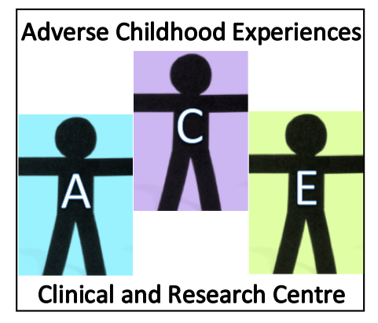

23 April 2021

9 am – 4.15 pm

**4th International Conference**

**Glasgow**

**VIRTUAL CONFERENCE**

**Webinar link will be sent approximately 2 weeks before event CONFIRMED**

***To secure a place at the conference complete the booking from***

***and send to:***

**Mrs Irene O’Neill, Academic Secretary,**

**Level 4, Academic CAMHS,**

**West Glasgow Ambulatory Care Hospital,**

**Yorkhill, Glasgow, G3 8SJ**

**Tel: 0141 201 9239 email:** [**irene.o'neill@glasgow.ac.uk**](mailto:irene.oneill@glasgow.ac.uk)

***An email confirmation will be sent to you.***

**(PLEASE PRINT CLEARLY)**

|  |  |
| --- | --- |
| **Name** |  |
| **Job title** |  |
| **Work place** |  |
|  |
| **Name of organisation** |  |
| **Email** |  |
| **Phone number(s)** |  |

|  |  |  |
| --- | --- | --- |
| **Delegate fee options** | **please ✓** | |
| **Standard fee** | **£60** |  |
| **Students** | **£40** |  |

**See next page for payment options**

|  |  |  |  |  |  |  |  |  |  |  |  |  |
| --- | --- | --- | --- | --- | --- | --- | --- | --- | --- | --- | --- | --- |
| **PLEASE CHOOSE ONE OF THE FOLLOWING**  **PAYMENT OPTIONS**  **tick relevant box and complete information as indicated** | | | | | | | | | | | | |
| **1** |  | **2** | |  | **3** | |  | | **4** |  | **5** |  |
| 1. **Paying via**   **NHS GG&C** | | | **Cost centre code** | | |  | | | | | | |
|  | | | | | | | | | | | | |
| 1. **Invoice** | | | **For the attention of:** | | |  | | | | | | |
| **Address** | | |  | | | | | | |
|  | | | | | | |
| **Any other relevant information, e.g. ref number** | | | | |  | | | | |
|  | | | | | | | | | | | | |
| 1. **Paying via Bank - Our BACS detail are:-** | | | **Quote reference number CG1574** | | | | | | | | | |
| **Name of Bank** | | | **ROYAL BANK OF SCOTLAND, GLASGOW CITY BRANCH,**  **8-10 GORDON STREET, GLASGOW G1 3PL** | | | | | | | | | |
| **Name of Account** | | | **NHS GREATER GLASGOW & CLYDE ENDOWMENTS** | | | | | | | | | |
| **Sort Code** | | | **83-07-06** | | | | | | | | | |
| **Account no.** | | | **10554856** | | | | | | | | | |
| **IBAN no.** | | | **GB27RBOS83070610554856** | | | | | | | | | |
| **SWIFT BIC** | | | **RBOSGB2L** | | | | | | | | | |
|  | | | | | | | | | | | | |
| 1. **CHEQUE** | | | **Payable to ‘Understanding Children‘**  **Send booking form and cheque to:**  Mrs Irene O’Neill, Academic Secretary,  Greater Glasgow and Clyde, Child and Adolescent Psychiatry,  Level 4, Academic CAMHS,  West Glasgow Ambulatory Care Hospital,  Yorkhill, Glasgow, G3 8SJ | | | | | | | | | |
|  | | | | | | | | | | | | |
| 1. **CASH** | | | **Contact Irene O’Neill - 0141 201 9239 / irene.oneill@glasgow.ac.uk** | | | | | | | | | |