TRAINEES
HOW TO UPDATE YOUR EMAIL ADDRESS AND/OR YOUR PERSONAL DETAILS IN TURAS TPM

Step 1

• Log into Turas.
• Click My Details.

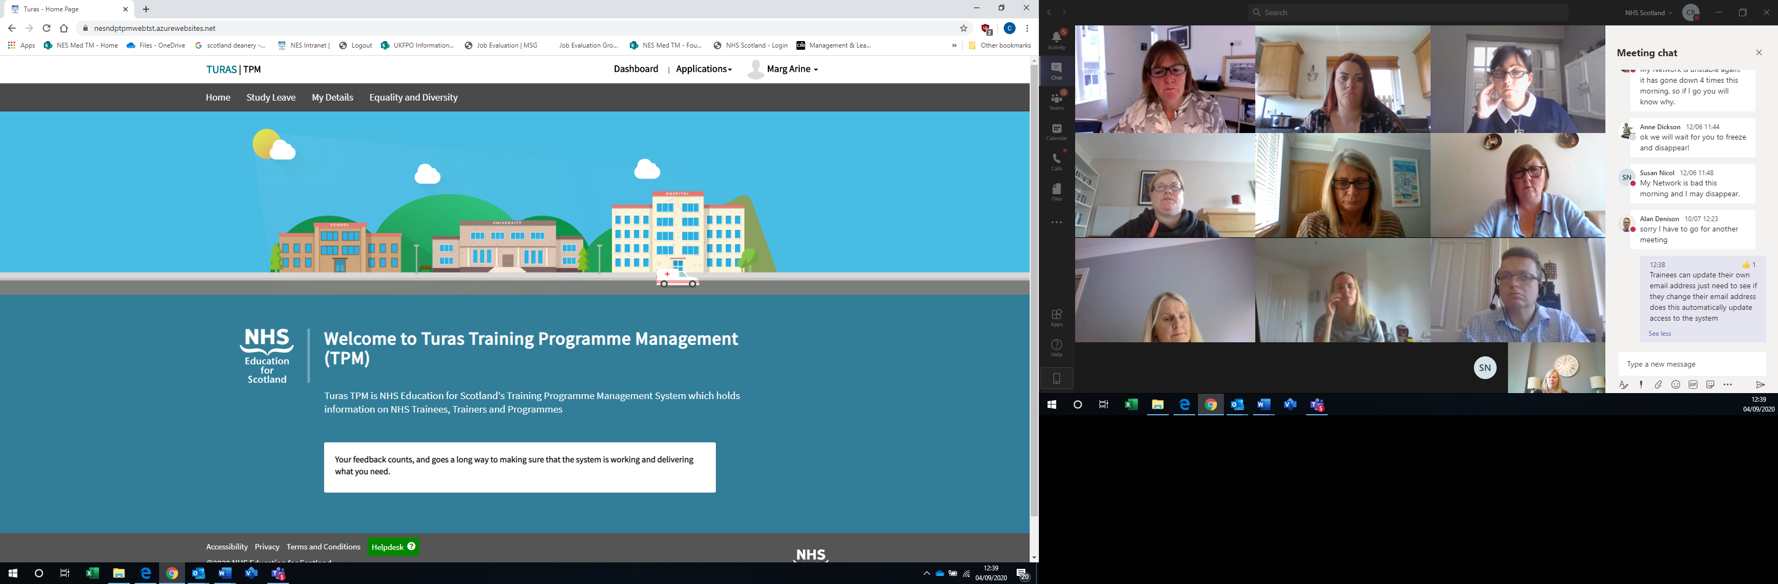

Step 2

• Click Edit.

Step 3

• Update your Personal Details – once done
• Click Save & Submit.

Step 4

• This will return you to your information page which is split into a number of different sections see below for explanation of each section.

Trainee Timeline - this shows the post you are currently occupying and clicking on the bar will show you the date and post type

Trainee Details – this section shows the personal details we hold about you please remember to keep your information up to date to allow your trainers and programme administration staff to contact you. This is key as we use this email address to inform you of key information about your training.

Grades and Levels – current, past and future grades and levels with the start and end date

You will find your National Training Number or Deanery Reference Number (if applicable)

Programmes – your current, past and future programmes

Posts – your current, past and future programmes

ARCP – details of your ARCP outcomes including any reason codes applied

Less Than Full Time - details of your applications (if applicable)

Out of Programme – Date and types of Time out of Training (TOOT) you may have had including Sick Leave

Trainers – your names Educational and Clinical Supervisors

Immigration Status – details of your Visa Type including start and end dates

Assessment – applicable to Dental Trainees only

If you notice any of the details, we hold about you are incorrect please immediately contact your Programme Administrator, who will be able to update them for you.

