Out of Programme approvals process (including Acting Up)– operational protocol

1. Introduction
It is recognised that there are a number of circumstances in which a specialty trainee may seek time out of training. The circumstances and overall process is already outlined within the Gold Guide 7th Edition
3.1143.142. (Foundation Trainees who wish to the take Time Out of Foundation Programme (TOPF) should take the following link on the Scotland Deanery website for more information http://www.scotlanddeanery.nhs.scot/trainee-information/scottish-foundation-
school/currenttrainees/time-out-of-foundation-programme-tofp/)

This protocol does not supersede those arrangements set out in the Gold Guide, but rather adds further clarity and support for those wishing to undertake time Out of Programme (OOP), detailing the strict requirements for application and approval.

These requirements must be adhered to and failure to follow the processes and timescales set within this document are likely to result in a request for OOP being rejected. Therefore, those wishing to undertake a period OOP are advised to thoroughly read this document and contact their Postgraduate Deans administrative office with in questions.

2. Process and principles - OOP

2.1 Application and approvals

Trainees may only go Out of Programme (OOP) with the prior written agreement of the Postgraduate Dean responsible for their training. For regional programmes this is the Regional Postgraduate Dean. For National Programmes, see Appendix 1, this is the relevant Lead Dean/Director

Applications to go OOP must be made by the application form for OOP/Acting up found on the ‘Out of Programme’
homepage on the Scotland Deanery website, which is based on the Gold Guide(Appendix 4).

There are set timescales that must be adhered to when making a request to undertake a period OOP. These timescales are in place to ensure there is a sufficient period for requests to be considered, provide more information if required, consider the impact on the wider training programme, ensure contractual notice periods are met and that appropriate backfill arrangements are in place, and to safeguard against any potential detrimental impact on service commitments

Timescales are as follows (also see figure 1):

o the application form is submitted to the Postgraduate Dean a minimum of six months in advance of the intended commencement date of the OOP
o if approved by the Postgraduate Dean, a minimum of three months’ notice is provided to the current
employer

Figure I illustrate the key time bound milestones when making an OOP request.

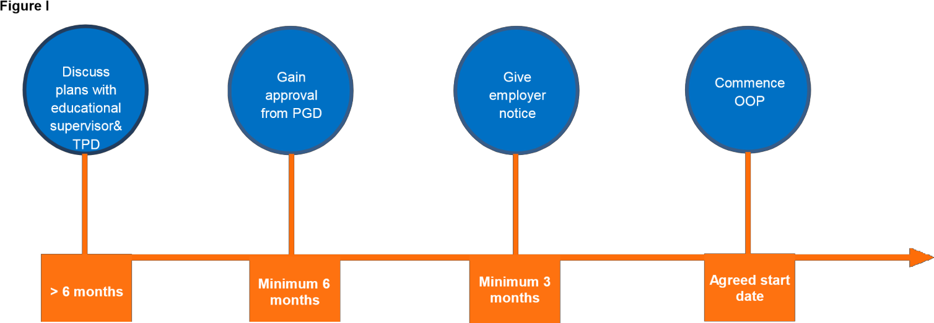

Those wishing to make an OOP application must be aware of these timescales and factor in when planning a period Out of Programme. Failure to meet these timescales is likely to result in an application being rejected. Those with concerns regarding the ability to meet these timescales should contact their Postgraduate Deans office to discuss at the earliest opportunity.

When requesting OOP, doctors in postgraduate training should be cognisant of the date they wish to commence in relation to their current contractual obligations and the rotation date of the wider programme, with as much alignment as possible. If necessary, the Postgraduate Dean may approve eligible applications with the caveat of an amended start date to ensure compliance with programme commitments.

In some exceptional circumstances, the Postgraduate Dean may exercise discretion with regard to the timing of submitting a request for approval, but only where there are reasonable extenuating circumstances. For example, those wishing to undertake an OOPC due to an unforeseen personal or health related matter. The timing of a research grant being awarded will not normally equate to an exceptional circumstance.

In most instances, periods OOP can only be taken with the agreement of the Training Programme Director (TPD) and Educational Supervisor (ES). Applications for OOP must contain signed support from the relevant TPD and current ES.

In some instances, the number of trainees wishing to go OOP during the same timeframe may potentially weaken either the adequacy of the education of the training programme or compromises patient- facing services. The threshold for this will be dependent on each specialty, programme and LETB/deanery arrangements.

Normally, OOP will not be approved in the final year of training. In some exceptional circumstances, the Postgraduate Dean may exercise discretion with regard to the timing of the
OOP.

2.2 ARCP requirements

Those wishing to apply for and undertake a period OOP are required to be in possession of a current satisfactory ARCP outcome. A satisfactory outcome constitutes an ARCP outcome
1. In some exceptional circumstances, the Postgraduate Dean may exercise discretion.

In some unusual instances, a doctor in postgraduate training who is currently undertaking a period OOP may wish to apply for an extension, or in exceptional circumstance, may wish to apply to undertake a different OOP opportunity before returning to his or her training programme. Where the current period of OOP relates to an OOPT, the requisite satisfactory outcome remains a current ARCP outcome 1.

Due to the nature of OOPC relating primarily to personal circumstance, in some instances possession of a current satisfactory ARCP outcome may not be feasible. For example, a doctor in postgraduate training may have mitigating health factors that have prevented satisfactory progression through their current training period. In such circumstances where a doctor is requesting an OOPC in relation to their personal circumstance, the requirement to hold a current ARCP outcome 1 may be waived at the discretion of the Postgraduate Dean/LDD. Instead, suitable evidence to substantiate current personal circumstance will normally be required, such as an Occupational Health report.

2.3 Programme requirements

If the number of trainees planning to go out a programme potentially weakens either the adequacy of the education programme or compromises patient-facing services, or where an “over subscription” of eligible OOP requests exists, Postgraduate Deans will need to determine an appropriate mechanism for determining priority. This may include discussion with individuals regarding flexibility over dates or giving priority to exceptional personal issues (OOPC) on compassionate grounds.

2.4 Employment status and continuous service

Trainees are advised to seek clarification from their employer in regard to their pension contributions and any statutory rights and benefits whilst undertaking a period OOP. The trainee should seek clarification about whether time OOP will represent a break in service and how pension contributions (if continued) will be made in relation to any relevant employer during their period OOP.

2.5 Prioritisation of Out of Programme time

OOPR

In general, the type of OOP may be prioritised according to what is being asked for. For example, if OOPR is being requested for a three-year PhD with peer reviewed external funding from a major charity (e.g. Wellcome, MRC, CRUK, etc) then it will be given a high priority, providing all requirements are otherwise met. "Soft money" projects or speculative projects may not be accorded the same priority. MDs will normally be granted 2 years OOP, but a clear outline of the project and its academic oversight will be required.

Ordinarily, other research projects will come further down in terms of allowing time out, though if enrolled on a PhD or MD by the university, should produce evidence that this is the case.

Time out is not normally allowed for taught courses, such as MSc degrees, which are largely now distance based or blended learning. Medical education degrees would only merit OOP if they were university based and lead to a higher degree such as an MD.

OOPT

There is extensive guidance on this on the GMC website that trainees should consult - (http://www.gmc- uk.org/doctors/seeking_approval.asp). Approval must be prospective, as it will count towards training time. Careful consideration of the merit of the OOPT will be made.

OOPE

This is granted to gain exceptional experience outside the region/programme, & will undergo careful scrutiny.

Normally, only one period of OOP will be granted during training, & the prioritisation and granting of the time out will depend on the careful balance between the benefit to the trainee and the detriment to the programme if gaps in training are excessive.

2.6 Extension to time OOP

Application for an extension to the previously agreed time OOP should be made by submitting a new form to the Postgraduate Dean. The most common reasons for requests for extension to time OOP are for maternity leave, sick leave, conversion of MD to PhD, issues related to the research project, family circumstances. This list is not exclusive and the Postgraduate Dean should be contacted for advice regarding extensions. The application for extension should include confirmation that funding can also be extended, if relevant.

3. Process and principles – Acting Up

3.1 For specialties that do not include acting up experience within their curriculum – list – the OOPE
process above must be followed.

3.2 For specialties that allow acting up experience within training the following process should be followed

o Trainees may only Act Up with the prior written agreement of the Postgraduate Dean responsible for their training.

o Applications to Act Up must be made using the application form for OOP/Acting up found on the
‘Out of Programme’ homepage on the Scotland Deanery website,

o Trainees must have the support of their TPD, the unit where their training post is based at the time of the acting up and the unit in which they would be acting up, including identifying a named supervisor.

Jul 2020

APPENDIX 1

Lead Dean/Directors for National Programmes

SPECIALTY GROUPING | LEAD DEAN/DIRECTOR | ADMINISTRATIVE REGION
Anaesthetics, Emergency Medicine & Intensive Care Medicine | Adam Hill  Adam.hill@nes.scot.nhs.uk | West
Dental (Core and Specialty) | David Felix | West
Diagnostics | Alan Denison  Alan.denison@nes.scot.nhs.uk | North
Foundation | Clare McKenzie  Clare.mckenzie@nes.scot.nhs.uk | East
General Practice, Occupational Health, Public Health, Broad Based Training | Amjad Khan  Amjad.khan@nes.scot.nhs.uk | South East
Medicine | Alastair McLellan  Alastair.mclellen@nes.scot.nhs.uk | West
Mental Health | Clare McKenzie  Clare.mckenzie@nes.scot.nhs.uk | North
Obstetrics & Gynaecology and Paediatrics | Alan Denison  Alan.denison@nes.scot.hs.uk | North
Surgery | Adam Hill  Adam.hll@nes.scot.nhs.uk | South East

