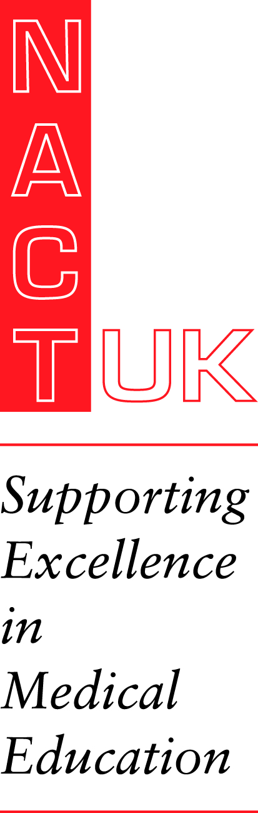
Your Future in Medical Education
Friday 12th June 2020
Macdonald Burlington Hotel, Birmingham New Street

DRAFT 6 PROGRAMME
The future of medical education: educational leadership through times of transition
For trainees considering a future in educational leadership

Objectives:
- to increase knowledge of educational leadership roles, structures and future direction of travel
- to be inspired by role models
- to learn about a topic that will support their own well-being but may also impact the way we work and train
- to present their own work to like-minded peers
- to meet and network with trainees and trainers with similar interests
- to learn about a key topical area of interest for all

09.00 Registration and Coffee

09.35 Welcome & Overview of the day

THE FUTURE OF EDUCATION
10.00 What HEE does for trainees in way of extra development: Andy Whallet, Deputy PG Dean
10.20 Jonathon Pinnell
10.30 Mind the Gap – Raising awareness of Differential Attainment, Laura Kelly
10.40 Anneka Varma
10.50 Q & As

11.00 COFFEE and Poster Viewing
11.30 Escape Rooms workshop TBC
12.30 Board Associate project, Becki Medlock
12.50 Q & As

13.00 LUNCH and Poster judging
13.45 3 trainees selected to present
14.00
14.15
14.30 Q & As

14.45 TEA
15.10 WARD, Ed Miles and Mark Eveleigh Help @ Well Doctors,
15.30 Title TBC Dr Emma Lishman, Jnr Dr Trainee Counselling, SRTT NHS Southmead Hospital
15.40 Q and As
16.00 CLOSE

