TRAINERS

HOW TO release a placement supervison group (psg) summary for an individual trainee

Step 1
Once logged into Turas, select the Portfolio application from your Turas Dashboard

Step 2

You will be taken to Educator Homepage.
- Select the trainee you wish to view.

Step 3

- Select the PSG tab
- Scroll to PSG Summary

Step 4

- Click – Create PSG Summary

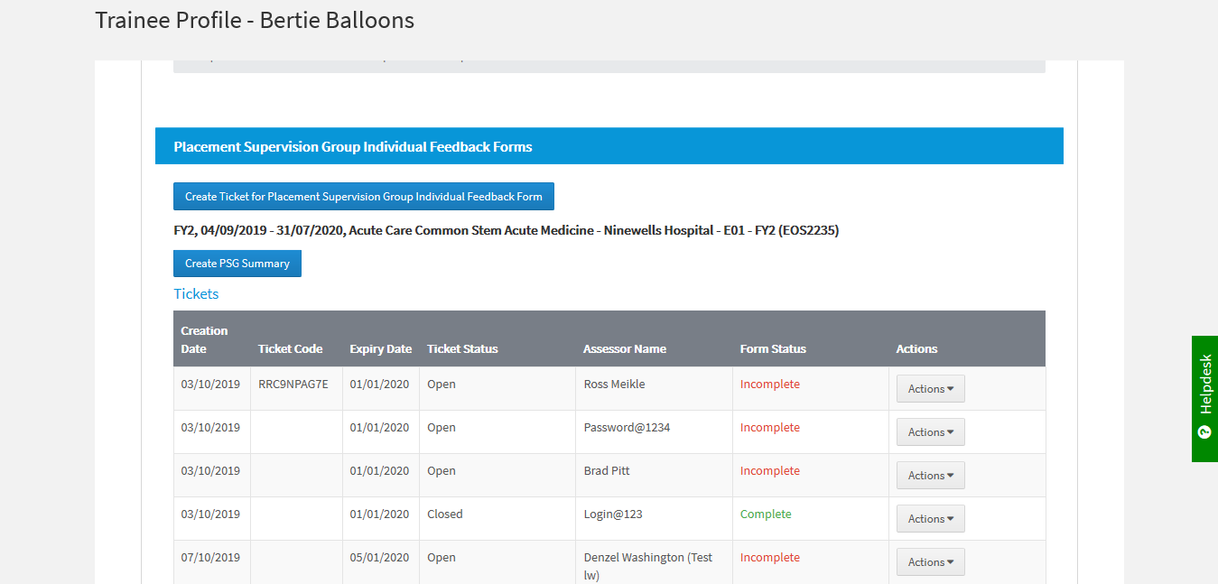

The Tickets Table allows the creator of the PSG to
- View the details of the request
- Send a reminder to the Assessor to complete a PSG for a trainee
- Delete Incomplete tickets
Click in the appropriate action required
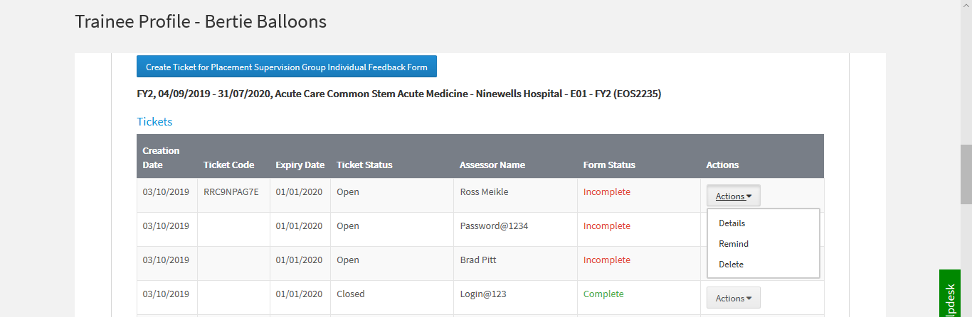

This table will change in the next few months and will show only incomplete forms.

To view the completed PSG forms
- Scroll to the PSG Forms section where the creator can view the detail in each from by clicking on the Actions dropdown before the Summary is created
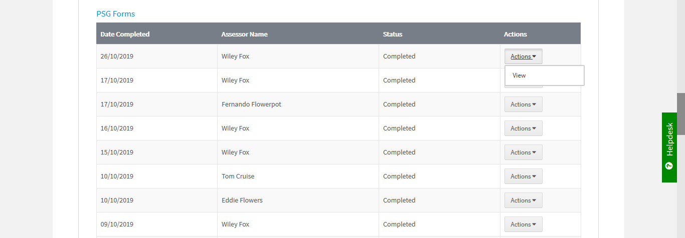

This table will change with the request to highlight any form(s) that may include a concern.

PSG Summary will be included on the updated end of placement form due to be release in the next few months.

Step 5
- Below is an example of the Feedback Summary
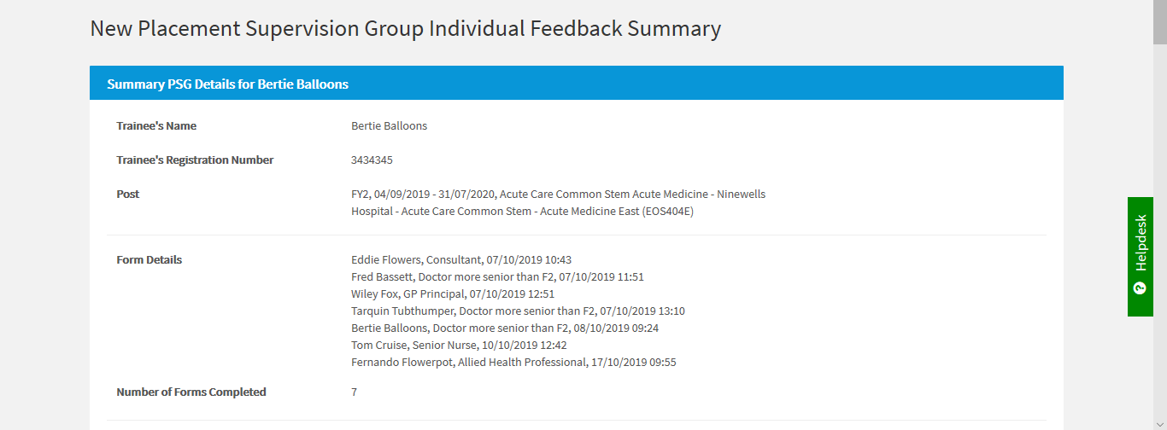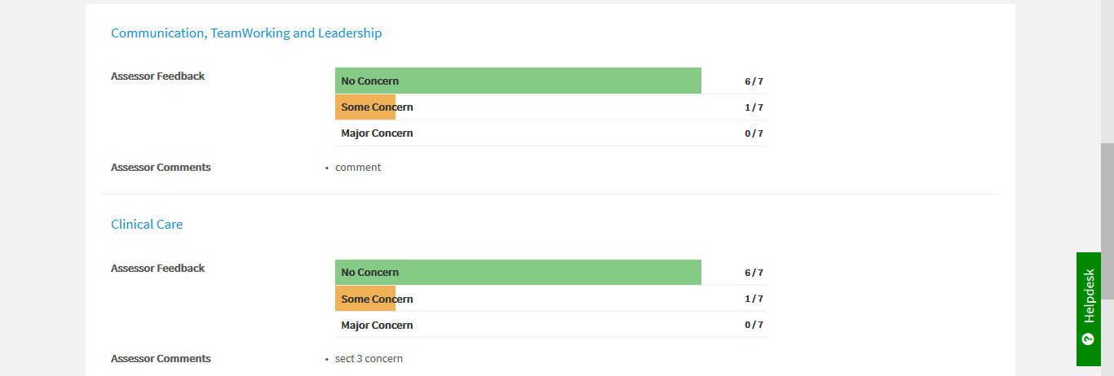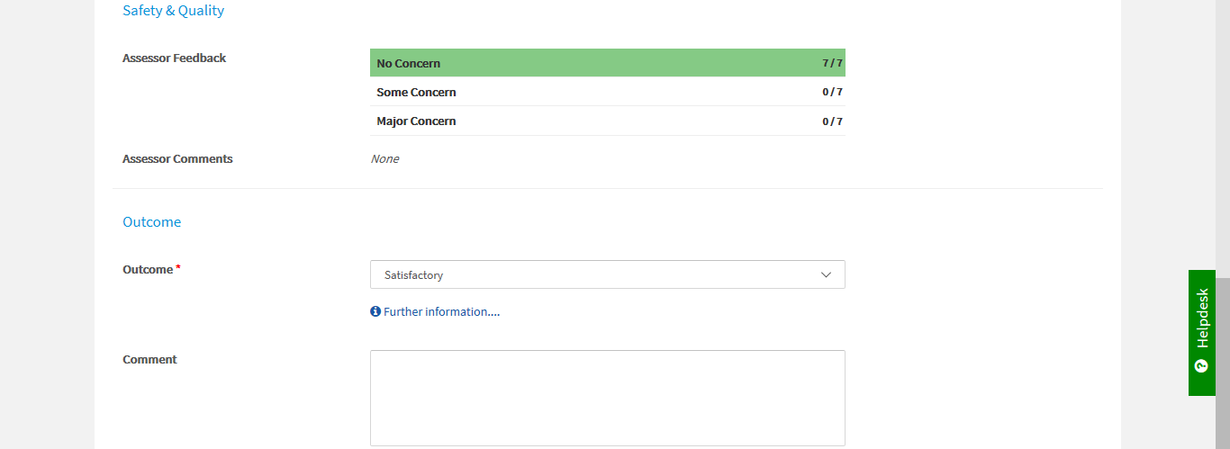
- The creator of the PSG can choose to release the form to the trainee
- Select Yes or No
- Click Submit
- User will be returned to the Trainees Profile page

