TRAINERS

HOW TO create a placement supervison group (psg) form

The Placement Supervision Group (PSG) Form is a non-mandatory form which can be used to add granularity to a clinical/educational supervisor’s report. There is no minimum or maximum number of assessors for a Placement Supervision Group (PSG) but can be from 2-3 senior colleagues and should be gathered in least one placement/rotation.
- Clinical supervisors, educational supervisors, foundation programme directors can all request and view feedback for foundation trainees if they have access to Turas Portfolio.
- It is expected that the clinical/educational supervisor identifies the members of the PSG at the trainee’s induction meeting and requests feedback before they complete their end of placement report.

“Whenever possible, the named clinical supervisor will seek information from senior healthcare professionals who will work with the foundation doctor during the placement. These colleagues will function as a placement supervision group, commenting on whether the foundation doctor’s clinical and professional practice is expected to meet or exceed the minimum levels performance required for sign off in each of the 20 foundation professional capabilities at the end of the year.”
FP Curriculum (2016) – Placement supervision group (p.23)

The named clinical/educational supervisor nominates the members of the PSG and is responsible for identifying them to the foundation doctor. The makeup of the placement supervision group will vary depending on the placement but is likely to include:
- Doctors more senior than F2, including at least one consultant or GP principal
- Senior nurses (band 5 or above)
- Ward pharmacists
- Allied health professionals
- In a general practice placement, the faculty may be limited to one or two GPs and AHPs in the practice
FP Curriculum (2016) – Placement supervision group (p.23)

Step 1
Once logged into Turas, select the Portfolio application from your Turas Dashboard

Step 2

You will be taken to Educator Homepage.
- Select the trainee you wish to view.

Step 3

Select the PSG tab

Once you have clicked PSG you will see the following Help information
What is a Placement Supervision Group?
Within any placement, an individual healthcare professional is unlikely to build up a coherent picture of the overall performance of an individual trainee. Whenever possible, the named supervisor will seek information from senior healthcare professionals who will work with the trainee during a placement. These colleagues will function as a placement supervision group (PSG), commenting on whether the trainees clinical and professional practice is expected to meet or exceed the minimum levels of performance required for sign off in each of the curriculum professional capabilities at the end of the training year.
The named supervisor will nominate the members of the PSG and is responsible for identifying them to the trainee. The makeup of the PSG will vary depending on the placement but is likely to include:
- Doctors more senior than F2, including at least one consultant or GP Principle
- Senior Nurses (Band 5 or above)
- Ward Pharmacists
- Allied Health Professionals
In a general practice placement, the faculty may be limited to one or two GPs
The PSG members' observations and feedback will inform the end of placement report. During certain placements, the trainee will only work with one or two doctors. In these cases, the pool of health care professionals making the assessment of performance will be smaller and the degree of interaction and number of interactions between the trainee and the trainer will be expected to be greater.

Responsibilites of the Placement Supervision Group
The PSG will help the supervisor form a balanced judgement of a trainee's performance, based on observations of the latter in the workplace and their engagement in the educational process. Such an approach will prevent any individual having undue influence over a trainee's progression. The PSG are responsible for:
- Observing the trainee’s practice in the workplace
- Undertaking and facilitating supervised learning events (SLEs)
- Providing contemporaneous feedback on practice to the trainee
- Providing structured feedback to the supervisor
- Raising concerns immediately if unsatisfactory performance by the trainee has been identified
The feedback from members of the PSG should indicate whether, in their opinion, the trainee’s clinical practice is expected to meet or exceed the minimum levels of performance required in order to allow sign off of each of the curriculum professional capabilities by the end of the training year.

Each section can be closed by selecting the +/- :

Step 4

Click – Create Ticket for Placement Supervision Group Individual Feedback Form

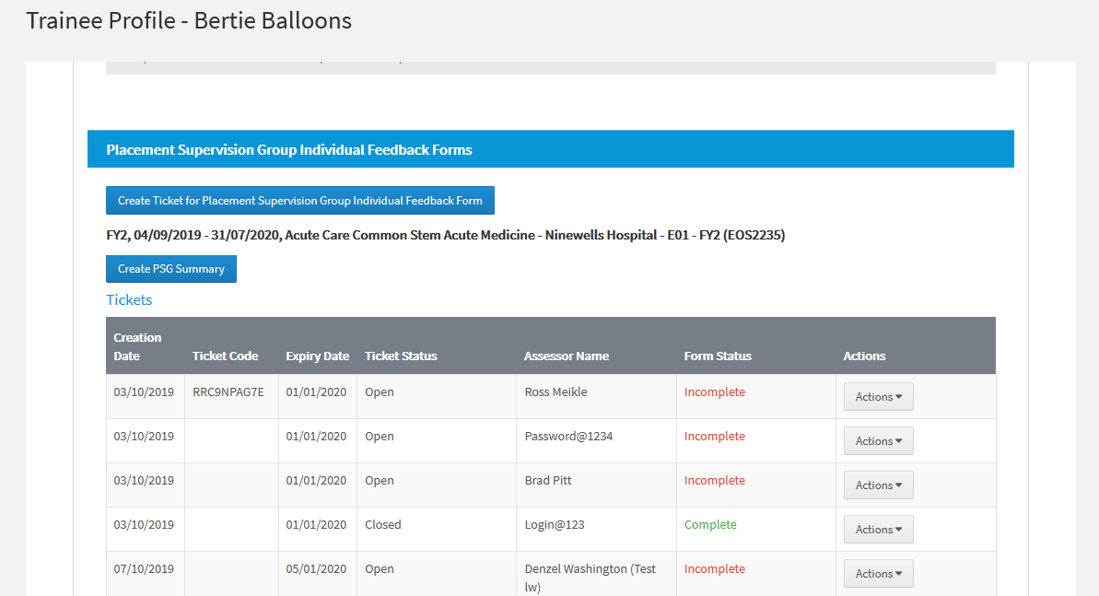

- Select the post you wish the PSG mapped to from the dropdown list.
- Click Next

Step 5

- Add the Email Address and the Name of the individual you wish to complete the PSG
- Click Next
- Add in any additional comments
- Click Submit
- You will be asked to confirm if they wish to submit request

Step 6

- Below is the example of the Ticket Confirmation which is sent the to the Assessor
- Click Return at the end of the page – returned to Trainees Profile page

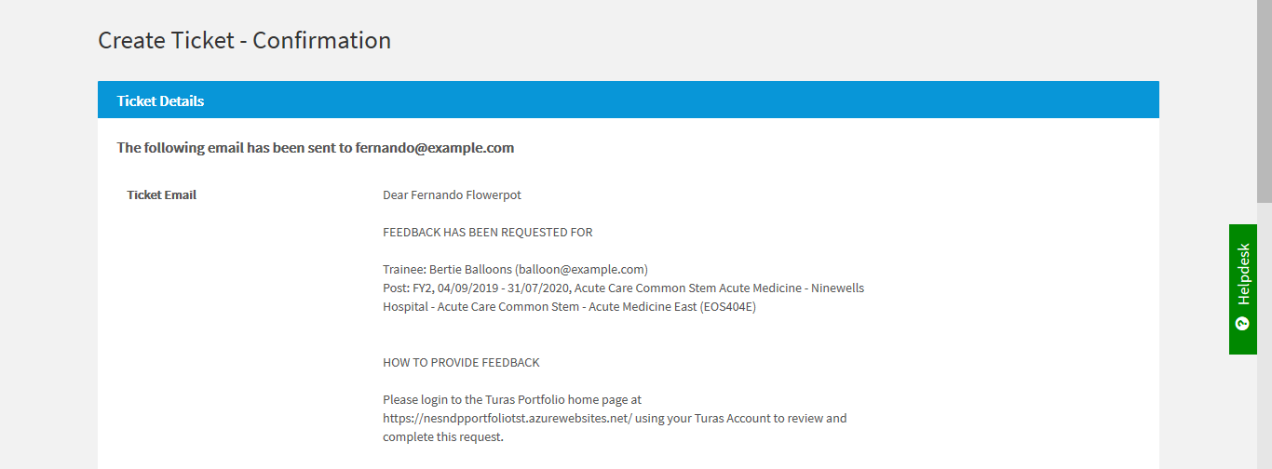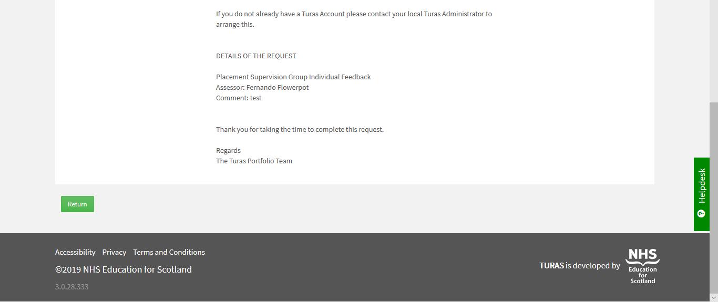

- You will need to create a form for each assessor you wish to be part of the PSG – repeat Step 4 to 6 until you have the included all assessors.

