TRAINERS

HOW TO complete a placement supervison group (psg) form

Step 1
Once logged into Turas, select the Portfolio application from your Turas Dashboard

Step 2

You will be taken to Educator Homepage.

- Click on View Ticket

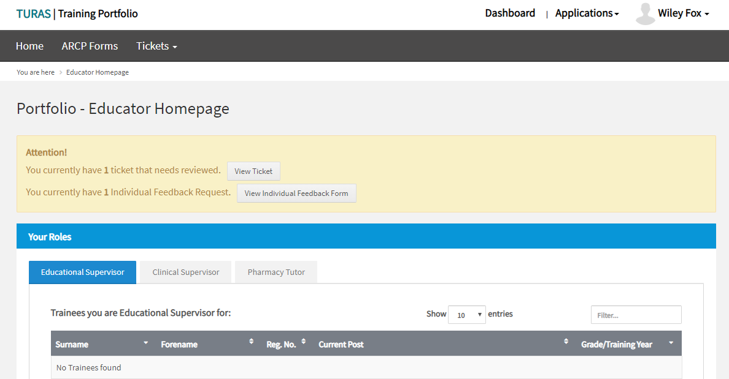

- Click Complete Ticket

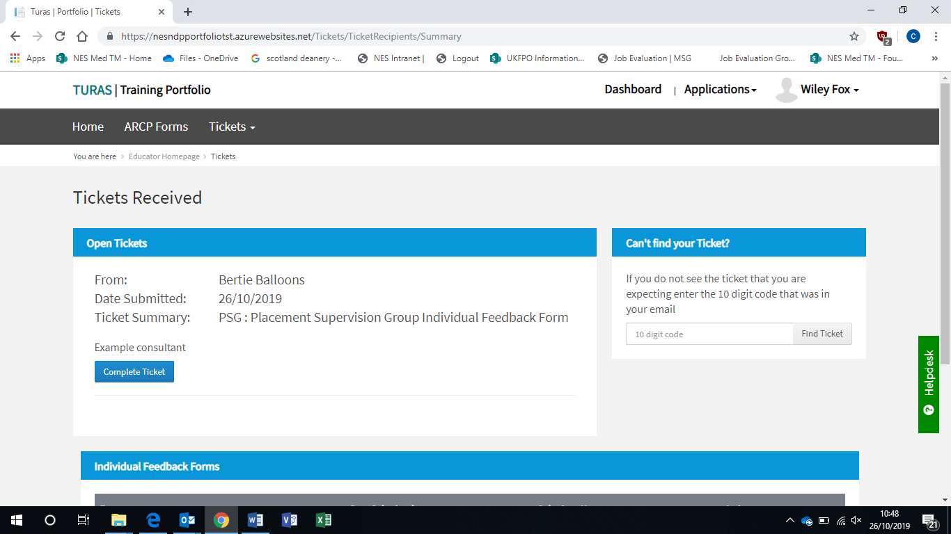

Step 3

You will be taken to the Ticket Details

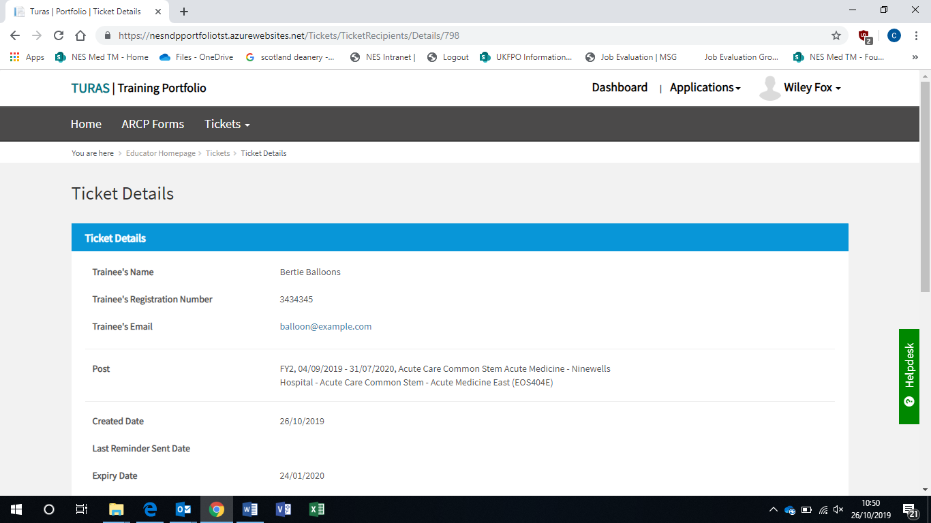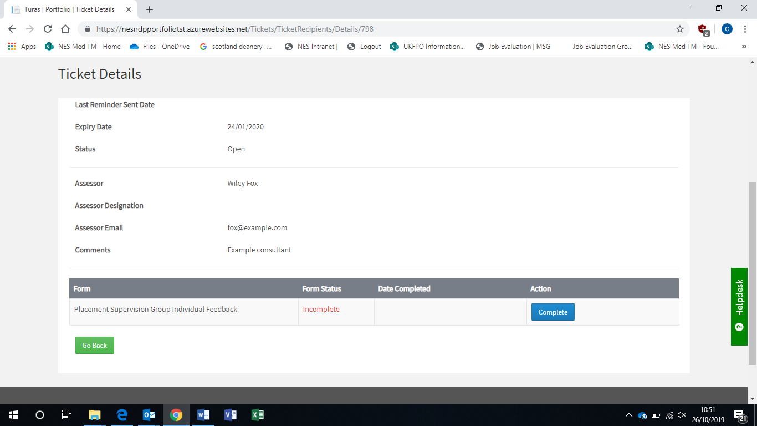

- Click Complete or Go Back to return to Tickets Received

Step 3

You will be taken to the Ticket Details

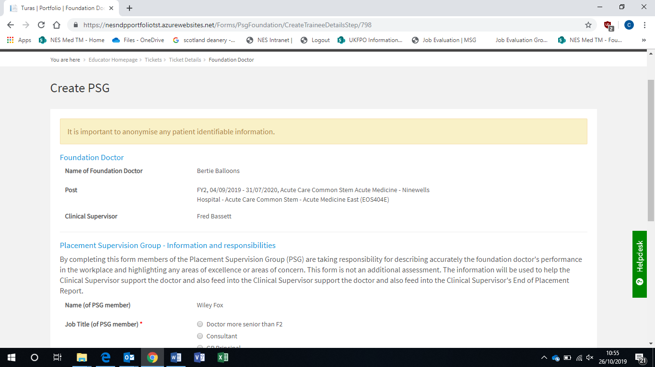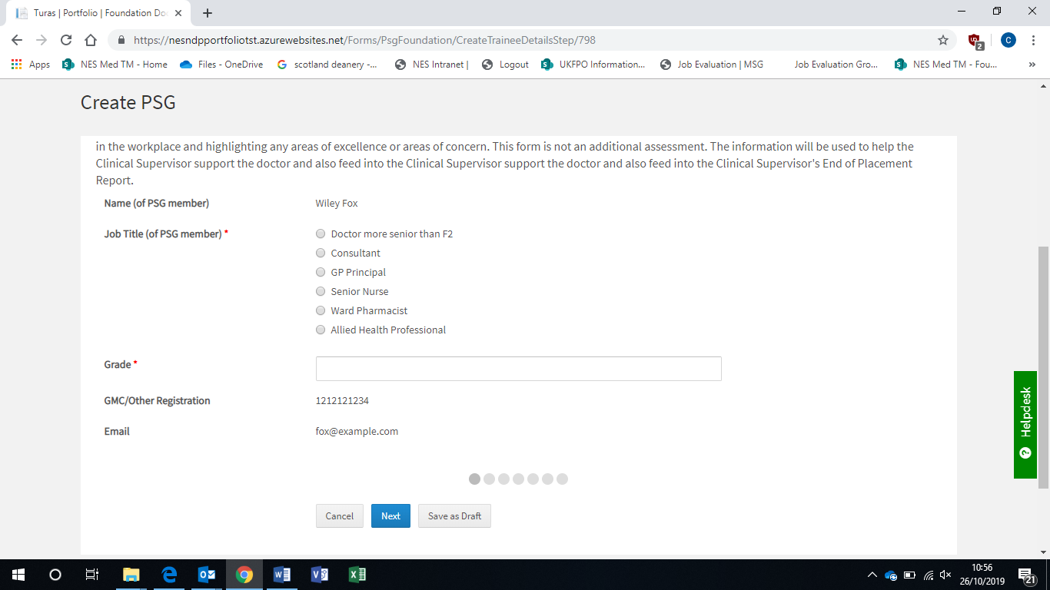

- Select Job Title
- Add Grade

As the Assessor you can select:
Cancel – to cancel out of the form
Next – to move to the next screen
Save as Draft – to save at a point in the form and return to complete at a later time

The Radio buttons will show the user how much of the form they have completed

Step 3

Click Next – Record of Supervision Learning Events
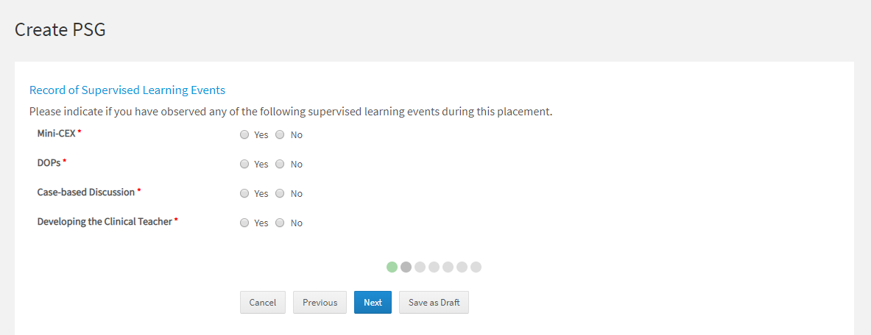
- Select Yes or No for each of the learning events you have supervised (note these are all mandatory fields)
- Click Next

- Complete each section by selecting the appropriate response from the drop-down list
- If you select “you have some concern”, or “you have major concern” under any of the sections the form will open and ask the assessor to provide additional comments
- If you select no concern you will move onto the next section

- There is also further information under each section. Click to open up the text, which links to the Foundation Professional Capability in the FP Curriculum 2016.

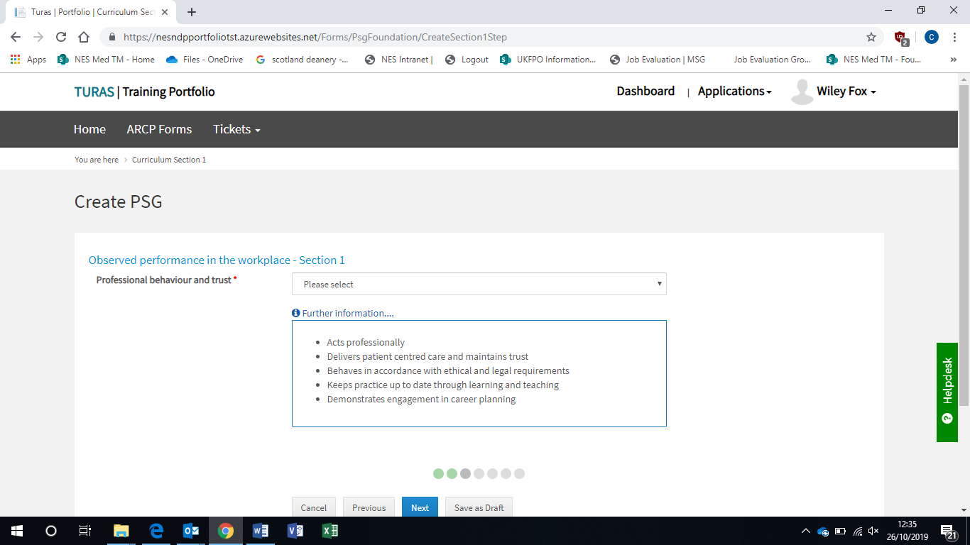

- If you select “you have some concern”, or “you have major concern” under any of the sections the form will open and ask the assessor to provide additional comments
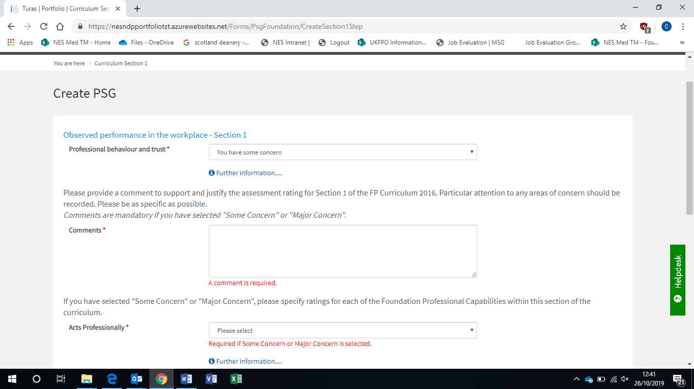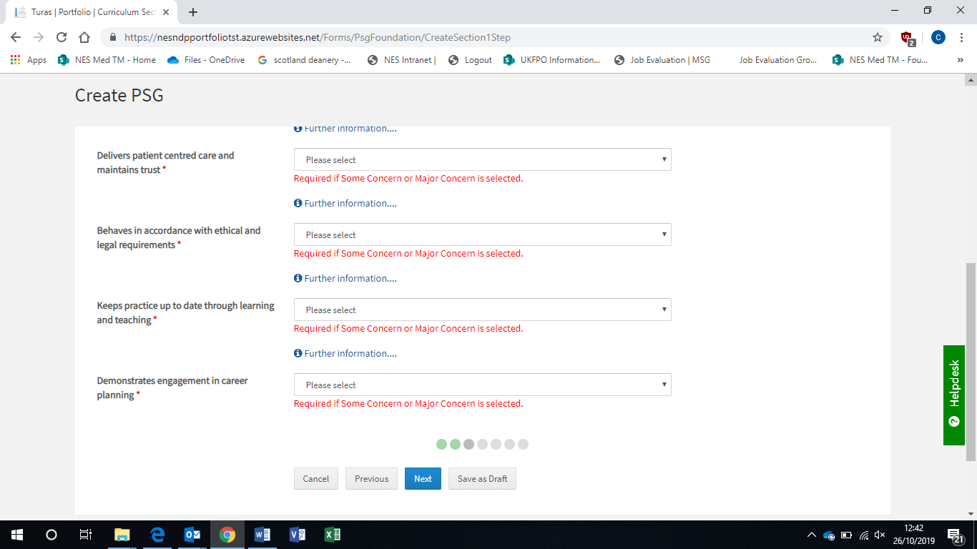
- Once completed click Next

- You must complete all 4 Sections with the appropriate selection from the drop-down list
- Once completed click Next
- Once completed click Next
- Once completed click Next

- There is a final section in the form for any other comments, which free text (non-mandatory). The assessor may use this section to highlight any other additional areas to the trainees e.g. areas of good practice and/or areas for further development
- Click Submit once completed
- The assessor will be asked to confirm submission before returning the ticket details page
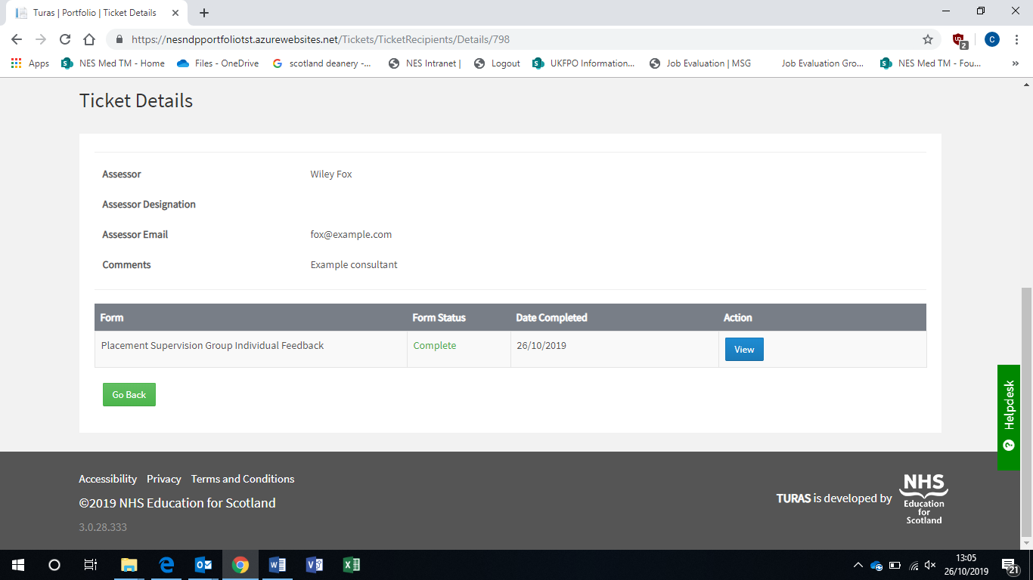
- The assessor will see the date the form was completed
- The assessor can also view their entry

