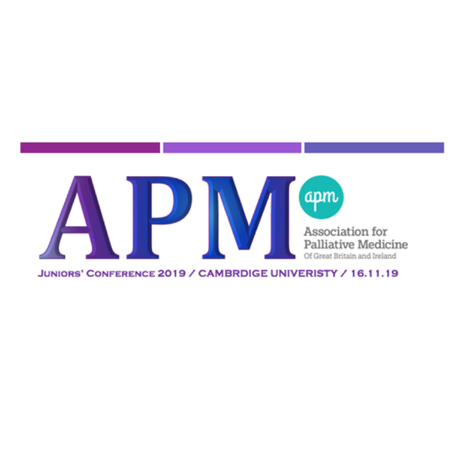
Abstract Competition Entry Form

Please submit ONE FORM per entry

The Association of Palliative Medicine Juniors’ Conference 2019 is welcoming abstract submissions for the oral and poster presentations. All accepted entries will be presented at the APMJ Conference 2019.

Deadline: 30th September 2019

Please submit abstract entries to conference.apmj@gmail.com with the information below: (All abstracts have a maximum word count of 300 words)

Title:

Authors (please underline any presenters):

Affiliations (e.g hospital or medial school):

Abstract (maximum 300 words):

Please include a contact email and if you wish to be considered for oral presentation

________________________________________________________

Thank you very much for your entry. We will be in touch with the outcome.

The APMJ Conference 2019 Committee

