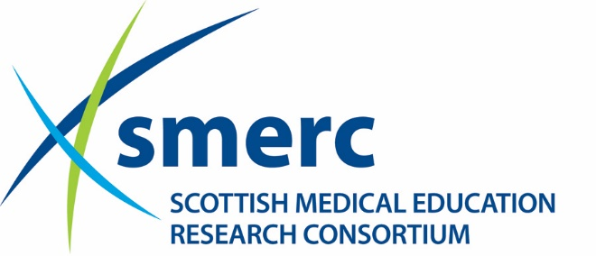

SMERC 2019-2020 Travelling Fellowship

Phase III SMERC project has provided the opportunity to fund up to £1,500 to provide one or more travelling fellowships.

The aim of the Fellowship is to provide financial support to an individual or a research group to facilitate gaining further experience/training/knowledge that will enable strengthening of health professional education research efforts in one or more of the NES/SMERC priority areas:
- Developing the workforce
- Developing the clinical learning environment
The individual or team must demonstrate commitment to a particular project and clearly indicate how the activities supported by the Travelling Fellowship will enhance the capacity to engage in conceptually grounded, methodologically rigorous, and programmatic research efforts in one of the five priority areas.
Applications will be considered where the Fellowship will be used:
- To enable an individual based in one of the SMERC collaborating institutions to visiting an institution or research group in furtherance of the individual’s own professional and personal development and collaborative opportunities.
- To enable an individual who has held or currently holds SMERC funding to present a SMERC project at a national or international conference/research meeting. This type of application will be more likely to be considered where the original funding request did not incorporate dissemination costs.
- To bring a scholar to Scotland in furtherance of developing research skills and knowledge of the individual, local team and SMERC. Where this is the focus of the application, a clear plan for sharing good practice and expert knowledge with the wider medical education and medical education research community should be set out in the application.
Key dates
The closing date for bids is at noon on Friday 13 September 2019. We expect to receive one electronic version of the application by noon on the closing date. The fellowship must be used in 2019-2020.

Eligibility
This opportunity is available to those active in medical education research in one of the SMERC collaborating institutions: NHS Education for Scotland, and the Universities of Aberdeen, Dundee, Edinburgh, Glasgow and St Andrews. Applications which are clearly linked to previously-funded SMERC projects or studentships, and contribute towards building research capacity building will be particularly welcomed.
Assessment of applications
All applications will be processed by the SMERC Administrator initially. Those which have not fulfilled the guidance will be rejected at this screening stage. The remaining applications will be reviewed by a small Panel of experts selected on the basis of their expertise.
Funding
Requests for amounts up to £1,500 will be considered. However, applications for smaller amounts are very welcome. If there are a number of good quality applications for smaller amounts, then there is the potential for funding more travelling fellowships, to the ceiling of £1,500.
Acknowledgement of support
Presentations, publications and other forms of media communication, including media appearances, press releases and conferences, must acknowledge the support received from SMERC.

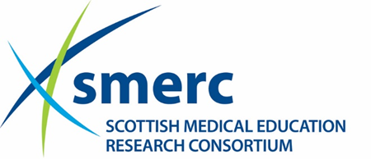

SMERC 2019-2020 Travelling Fellowship Application Form

Name:
Current Post:
Tel no:
Institution/Address:

Email:

Proposal title:
Please address the following four questions in 1000 words or less. The word count should be provided at the end of the application. Please strictly adhere to the stipulated word limit or your application will be rejected.
- How will the travelling fellowship be used (including specific dates, institutions, and individuals involved)?
- What priority area will be addressed and what advance in understanding do you anticipate being gained.
- Please provide evidence of prior experience in medical education research and justification regarding what will be gained from receipt of funding.
- What local supports are in place to ensure that the experience enabled by the travelling fellowship will have a sustainable impact?

Please outline and justify estimated costs up to £1500 (200 words).

PhD student applications
If you are a PhD student, please provide details of your supervisory team (200 words).
Please complete the form with your signature and ensure it is co-signed by one supervisor.

Please submit your application to: Pat MacLennan (pmaclennan@abdn.ac.uk) by noon on Friday 13 September 2019.

