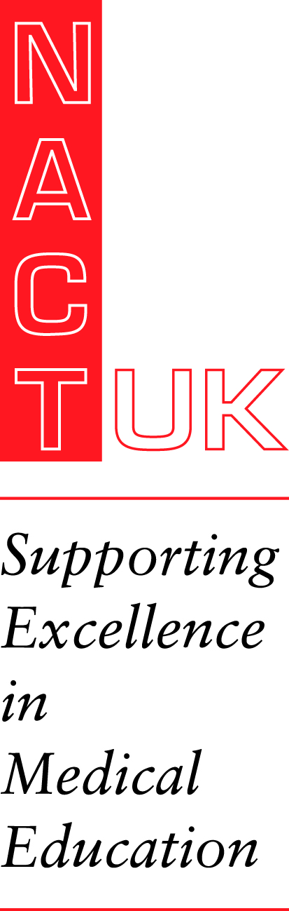
Your Future in Medical Education
Tuesday 14th June 2022
Macdonald Burlington Hotel, New Street, Birmingham

The future of medical education: educational leadership through times of transition
Call for Papers
Dear Colleague,
You are invited to submit abstracts concerned with any innovations / developments in any area of postgraduate medical education or training that has worked well and could be shared with others.
3 abstracts may be selected for verbal presentation on the afternoon of 14th June 2022
Abstracts will also be selected for poster presentation on 14th June 2022 when there will be an opportunity to present your poster verbally.
Guidelines
- The abstract should not be more than 200 words in length
- Please use the following headings:
- BACKGROUND
- METHODS
- RESULTS
- KEY MESSAGES
- REFERENCES - Vancouver style

Deadline for abstracts is Monday 14th March 2022

If your abstract is selected, you must register as a delegate
We look forward to receiving your abstract & completed Submission Form (see overleaf)
Details of this conference can be found at www.nact.org.uk
For further information contact the NACT UK office: 01908 272898 or office@nact.org.uk

Abstract Submission Form – 14th June 2022
Deadline: Monday 14th March 2022
This form will be held by NACT UK for one year, and then disposed of securely in accordance with the new General Data
Protection Regulations and our privacy policy details of which can be found on our website.
By signing here you agree to the above ………………………………………………………

(One form per abstract - photocopy if necessary) Please email your submission form and abstract to office@nact.org.uk

Format: Calibri, 12 pt font, single line spacing, in the space below, using the headings: Background, Methods, Results, Key Messages and References.

Please do not use headers or footers or put footnotes in your document.
Title of paper:
Corresponding author/contact details (this contact will receive all correspondence):
Name (including title):
Address:
Mobile Tel:
Email:
Names of co-authors:
Name of presenter
Abstract:
I/we confirm that the abstract has not been published elsewhere:
The abstract has been published elsewhere and written copyright permission is attached:
I/we would prefer the abstract to be considered as either:
Oral or Poster presentation OR Poster presentation only OR Workshop

