TRAINEES

HOW TO LINK AND UNLINK EVIDENCE TO THE CURRICULIUM

Step 1
Once logged into Turas, select the Portfolio application from your Turas Dashboard

Step 2
You will be taken to your Portfolio - Trainee Homepage. Here you will be able to access:
- forms you may need to acknowledge
- view your ticket status
- view my progress summary. Click on the + beside each area to open up to view your progress at a glance
- start a quick reflection
- view current status - this section includes your current grade/training level, post start/end date, location (Education Provider), specialty, your named Educational and Clinical Supervisor and Programme Director. To contact any of the named trainers, click on the name and this will open your email browser.

If you find that any of this information is incorrect you need to contact the relevant Foundation School.

Step 3
To link and unlink evidence, click Curriculum & PDP from the tool bar to open the drop-down list. For this example, click F1 Curriculum.
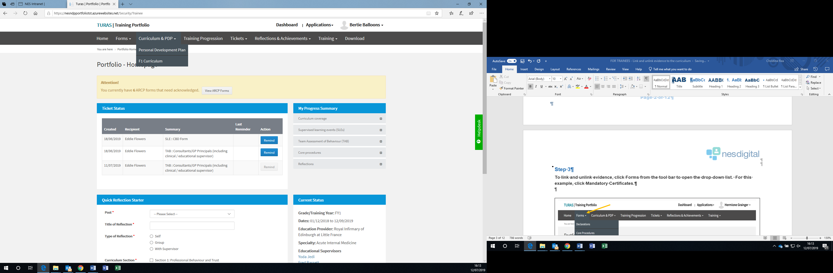

Step 4
Once you have clicked on F1 Curriculum from the drop-down this will open a new window. The “What you need to know” section provides you with helpful information and descriptors - What is the Foundation Training Programme Curriculum? How do I link evidence to the Curriculum? and How much evidence and what type of evidence should I link? To access these, click on the +.

Under each capability you will also find a link to View Guidelines for each of the capabilities.

To add a new link, click on the Actions button next to the capability on the Curriculum or directly from a completed assessment.

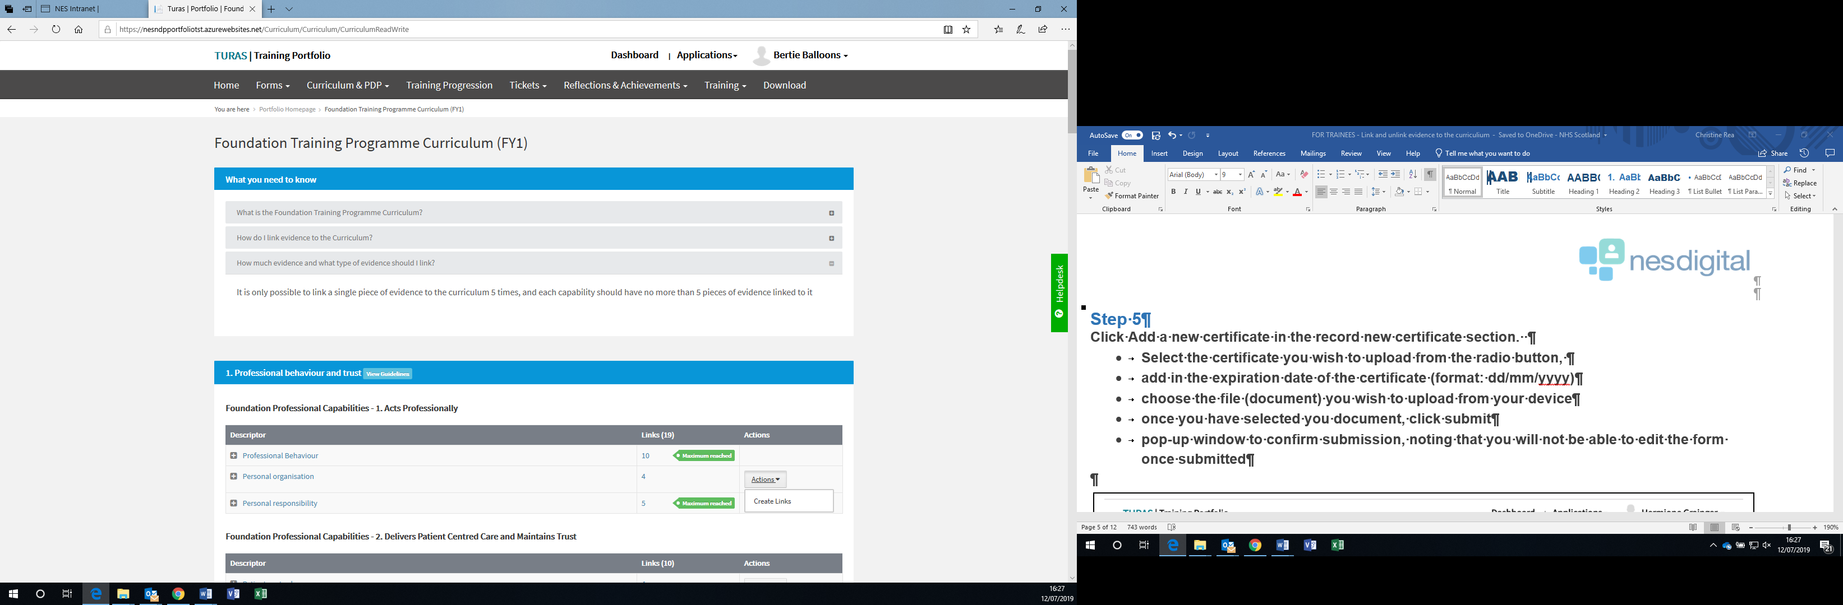

Step 5
Click Actions next to the capability to which you wish your evidence to be linked.
- Click Create Links
- Step 1: Select Type of Link
- From the drop-down select the Type of Link
- Click Next
- Step 2: Select Items to Link
- Click the checkbox of the item you wish to link
- Click submit
- A pop-up window appears asking you to confirm submission

Step 6
Once you’ve selected to submit you will be taken back to the Foundation Training Programme Curriculum (FY1) page. The number of Links against that capability will update.

If you have reached the maximum allowed links, the following will appear next to the capability and there is no option to select an action.

Step 7
To remove a link:
- Click on the descriptor; this will open up the evidence already linked
- Click the evidence you wish to remove
- Select Remove Link
- Action box appears
- Click Remove
- A pop-up window appears asking you to confirm if you wish to remove the link

Step 8
Once you’ve selected to submit you will be taken back to the Foundation Training Programme Curriculum (FY1) page. The number of Links against that capability will update and you can then add a new Link. Follows Steps 4-5 to add a new piece of evidence.

